Year 12 ATAR
PHYSICS

Unit 3

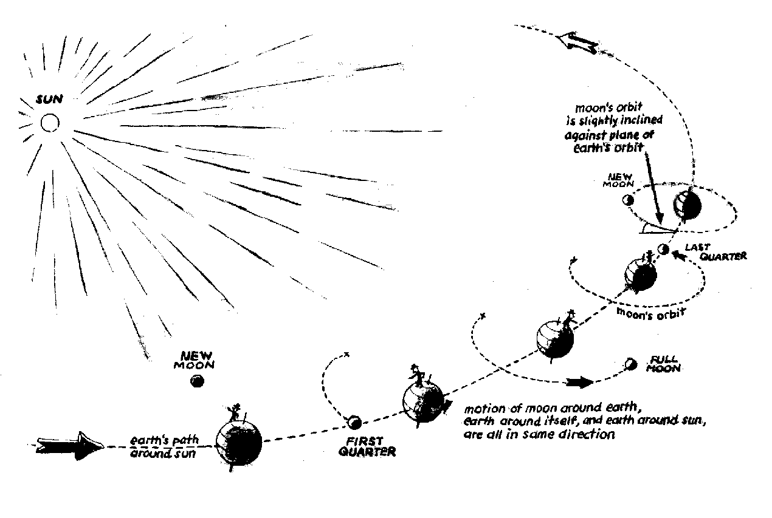

Gravity and Motion

Year 11 Review

Fundamental Units
Mass kilogram (kg)  Length metres (m)  Time seconds (s)  Electric current ampere (A) | Temperature Kelvin (K)  Luminous intensity Candela (cd)  Amount of substance mole (mol)

Derived Units
- A combination of fundamental units.
- ms⁻² or m/s² (speed), kW.h (electricity), kgm⁻³ or kg/m³ (density).
- Some derived units are given their own unit for simplicity.
- Force F = ma would have a derived unit of kg ms⁻² but is given the unit newton (N).

Prefixes
- These are helpful for large or small numbers.
Name | Symbol | Orders of magnitude |  |  | Description
nano | n | 10⁻⁹ | = | 0.000 000 001 | one thousand millionth
micro | μ | 10⁻⁶ | = | 0.000 001 | one millionth
mili | m | 10⁻³ | = | 0.001 | one thousandth
centi | c | 10⁻² | = | 0.01 | one hundredth
kilo | k | 10³ | = | 1 000 | one thousand
mega | M | 10⁶ | = | 1 000 000 | one million
giga | G | 10⁹ | = | 1 000 000 000 | one thousand million
tera | T | 10¹² | = | 1 000 000 000 000 | one million million

Use of Significant Figures

- The correct number of significant figures must be used in your numerical answers.

- A small proportion of the marks for your assessments and ATAR Examination will relate to the correct use of significant figures and units.

- Usually three significant figures, estimate questions have no more than two significant figures (usually one). Sometimes they ask for appropriate number of sf.

- For large or small numbers, give your answer in scientific notation. For example, 98 344 N to three significant figures is 9.83 x 10⁴ N and 0.000023403 to three significant figures is 2.34 x 10⁻⁵.

- Wherever possible, leave the rounding off till the very end. Some calculations involve multiple steps and rounding off at each step could cause an error in the final answer.

- How many significant figures in the following?
a. 125 b. 0.013 c. 1007 d. 25.10 e. 630
2. Convert the following to three significant figures and in scientific notation.
a. 34 791 b. 0.000 034 53 c. 3 478
3. Multiply 2.340 by 5.29002
3. Multiply 2340 by 550
4. Subtract 0.984 from 5.6
Uncertainty and Absolute Error

Uncertainty:
- All measurements you make have some amount of uncertainty.
- Unless given, the uncertainty of an instrument is usually one half of the finest scale e.g. a ruler which measures in mm has an uncertainty of 0.5 mm. An electronic timer usually to 0.005 s.
- Although a timer has a small uncertainty, human error needs to be incorportated.
Uncertainty in common laboratory equipment:
Metre rule ± 0.05 cm Micrometer screw gauge ± 0.005 mm
50 mL measuring cylinder ± 0.2 mL Vernier Callipers ± 0.005 cm
50 mL measuring cylinder ± 0.2 mL 10 mL measuring cylinder ± 0.1 mL
-10⁰C – 110⁰C thermometer ± 0.5⁰C (does depend on precision of thermometer)
Estimating the uncertainty in a result
- The following three processes are used for estimating uncertainty.
- When adding or subtracting data, add the absolute uncertainties.
e.g. ΔT (change in temperature) = 40 ± 0.5 ⁰C - 35 ± 0.5 ⁰C = 5 ± 1 ⁰C
- When multiplying or dividing data, add the percentage uncertainties.
- When raising data to power n, multiply the percentage uncertainty by n.

- Measuring specific heat of a metal
Use the data in the table to determine the power of the student and the associated uncertainty.
$$mcΔT=mcΔT c= \frac{mcΔT}{mΔT}$$

Suppose you had the following data included in your results:
Quantity |  | Absolute uncertainty | % Uncertainty
m (water) | 0.149 kg | 0.001 kg
c (water) | 4180 | 10 J kg⁻¹ ⁰K⁻¹
ΔT (water) | 2.0 ⁰C | 0.1 ⁰C
m (metal) | 0.043 kg | 0.001 kg
ΔT (metal) | 75.0 ⁰C | 0.1 ⁰C

c =

Specific heat of metal is

Uncertainty (%) =

Hence: c = J kg⁻¹ ⁰K⁻¹ ± %
now % of =
so c = ± J kg⁻¹ ⁰K⁻¹

Therefore, you could confidently say that the power of this person during this exercise was
J kg⁻¹ ⁰K⁻¹ ≤ c ≤ J kg⁻¹ ⁰K⁻¹

Graphical analysis of data

- Some relationships studied in physics are linear, while others are not.
- It is possible to manipulate non-linear data so that a linear graph reveals a measurement.

Linear Relationships

- Linear relationships and their graphs are fully specified with just two numbers: gradient, m, and vertical axis intercept, c. In general, linear relationships are written as:

y = mx + c

- The gradient, m, can be calculated from the coordinates of two points on the line:

m = $\frac{rise}{run}$ = $\frac{y2 - y1}{x2 - x1}$

where (x₁,y₁) and (x₂,y₂) are any two points on the line.

- Note: Don’t forget that m and c have units. These need to be given in assessments.

Example:
- Some students used a computer with an ultrasonic detector to obtain the velocity-time data for a falling tennis ball. They wanted to determine the acceleration of the ball as it fell. They assumed that the acceleration was nearly constant and that the relevant relationship was v = u + at, where v is the speed of the ball at any given time, u was the speed when the measurements began, a is the acceleration of the ball and t is the time since the measurement began. Their computer returned the following data:
Time (s) | Speed (ms⁻¹)
0.0 | 1.25
0.1 | 2.30
0.2 | 3.15
0.3 | 4.10
0.4 | 5.25
0.5 | 6.10
0.6 | 6.95

- The data is assumed linear with the relationship v = u + at, which can be thought of as being v = at + u, which makes it clear that putting v on the vertical axis and t on the horizontal axis gives a linear graph with gradient a and vertical intercept u. A graph of the data can now be drawn on the following grid.

Velocity-Time profile for a falling tennis ball.
8

6

4

2
Velocity (ms ⁻¹)
0 0.1 0.2 0.3 0.4 0.5 0.6 0.7 0.8 0.9 1
Time (s)

- Using computer software, the regression line is given as y = 9.57x + 1.2857.
- If this is rearranged and the constants are suitably rounded, the equation is v = 1.3 + 9.6t.
- This indicates that the ball was moving at 1.3 ms⁻¹ at the commencement of data collection
(i.e. u = 1.3 ms⁻¹) and the ball was accelerating at 9.6 ms⁻².

- NOTE – if the point (0,0) is not in your data, DO NOT ‘force’ the line of best fit through the origin.
- When finding the gradient, use as big an area as possible. Select suitable points that are not from your data.
- Show all working on your graph. This includes construction lines to determine gradient and interpreting data from the graph.

Manipulating non-linear data

- Suppose we were examining the relationship between two quantities, pressure P and volume V, and had good reason to believe that the relationship between them is :
P = $\frac{c}{V}$ where c is a constant value.
- This relationship is hyperbolic (non-linear) and a graph of P against V will not be a straight line.
- By thinking about the relationship it can be seen that in ‘linear form’:

P = k $\frac{1}{V}$ which can be seen as

y = m x + c

- Graphing P (on the vertical axis) against $\frac{1}{V}$ (on the horizontal axis) will be linear.
- The gradient of the line will be c and the vertical intercept, c, will be zero.
- This line of best fit might go through the origin because there is no constant added and c is zero.

- Some students were investigating the relationship between current and resistance for a new solid state electronic device. They obtained the data shown in the table.

Current, I (A) | Resistance, R (Ω)
1.5 | 22
1.7 | 39
2.2 | 46
2.6 | 70
3.1 | 110
3.4 | 145
3.9 | 212
4.2 | 236
Resistance and Current of an electronic device.
Resistance (Ω)
250

200

150

100

50
0 1 2 3 4 5
Current (A)

- According to the theory they had researched on relevant Internet sites, the students believed that the relationship between I and R is R = d I³ + g, where d and g are constants. From this,

R = d I³ + g which can be seen as

y = m x + c
- A graph of R on the vertical axis and I³ on the horizontal axis would have a gradient equal to d and a vertical axis intercept equal to c.

- By appropriate manipulation and graphical techniques, find their experimental values for d and g. The following steps would be used:

- Work out what you would have to graph to get a straight line. (i.e. I³)
- Make a new table of the manipulated data.
- Plot the graph of manipulated data.
- What is the equation relating I and R?

Current, I (A) | Resistance, R (Ω) | Current cubed , I³ (A³)
1.5 | 22
1.7 | 39
2.2 | 46
2.6 | 70
3.1 | 110
3.4 | 145
3.9 | 212
4.2 | 236

Resistance and Current of an electronic device.
Resistance (Ω)
250

200

150

100

50
0 20 40 60 80 100
Current cubed (A³)

- From the graph m = c =

- From a computer based spread sheet, a graph with the following regression line was obtained:
y = 3.1412 x + 15.092
- This equation can be written as y = 3.1 x + 15.1, so the equation relating I and R is
R = 3.1 I³ + 15.1.
- Hence, the value of d is 3.1 ΩA⁻³ and the value of g is 15.1 Ω.

Consider the following formulae and answer the questions relating to graphing.

- Two similar electrostatic charges, of known value, are placed at a set distance apart and the force of repulsion is measured. The distance is increased at set amounts and the force is measured each time. The relationship between force (F) and distance (r) is given as

where q₁, q₂, π and ε₀ are constants.

  - Would a graph of F v’s r produce a straight line?

  - If no, how would you manipulate the data to get a straight line?

  - Would the line pass through 0,0?

  - What would the slope of the graph equal?

- In the photoelectric effect, light is shone onto a metal surface and electrons are emitted. The energy of the emitted electrons (E_{k}) is related to the frequency of light (f) that is shone onto the surface of the metal. The relationship is given as

where h is Planck’s constant and W is also constant.

In an experiment, the frequency of light was changed and the energy of the electrons was measured.

  - Would a graph of E_{k} v’s f produce a straight line?

  - Would the line pass through 0,0?

  - If no, what would the y-intercept equal?

  - What would the slope of the graph equal?

- When satellites orbit the Earth, there is a relationship between the period of revolution (T) and radius of the satellite’s orbit (r).
Data for period and radius for satellites can be easily collected.
The relationship is given as

  - Would a graph of T v’s r produce a straight line?

  - If no, how would you manipulate the data to get a straight line?

  - What data would you place on each axis?

  - Would the line pass through 0,0?

  - If G and π are constant, how could you work out the mass of Earth, M?

Gravity and motion
The movement of free-falling bodies in Earth’s gravitational field is predictable.

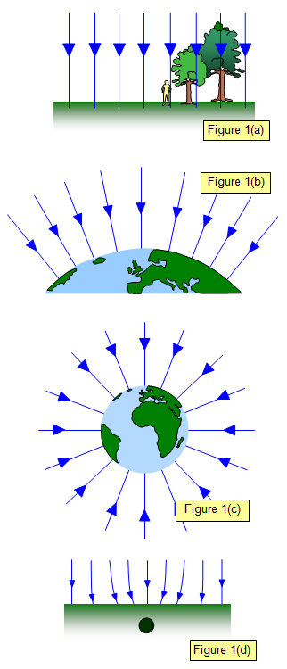
- The Earth, because it has a large mass, has a gravitational field. This gravitational field is directed towards the centre of the Earth. At the surface, it will be straight down and uniform.


- At a distance away, the field will be a spherical pattern.
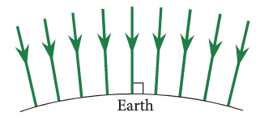

- Any object that has mass will be influenced by this field.
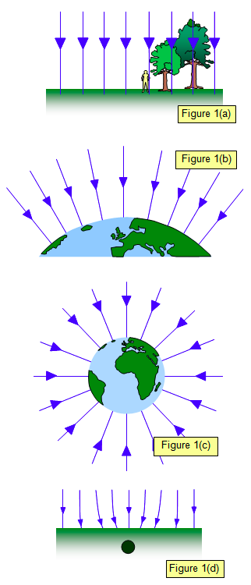
- A free-falling object will move along these field lines, towards the Earth.

- The field, produced by the Earth, can be distorted by high-density rocks.

- A ball thrown horizontally, close to the Earth’s surface, will move in a parabolic path. This is due to a combination of its initial velocity and the influence of the gravitational force.
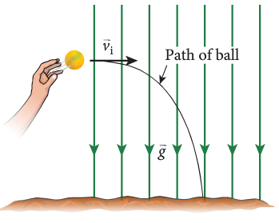

All objects with mass attract one another with a gravitational force; the magnitude of this force can be calculated using Newton’s Law of Universal Gravitation.
This includes applying the relationship

Gravitational Force
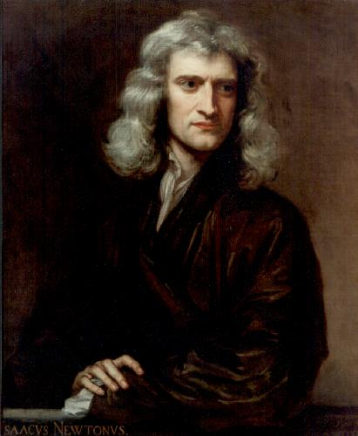
- Sir Isaac Newton’s talent for clear thinking provided most of the logical framework for our modern understanding of motion of everyday objects.

- He explained the forces that attract falling objects towards the Earth and why satellites stay in orbit.

- He found that all object attract each other with a force that is proportional to the product of their masses and inversely proportional to the square of their distance apart.
So

- This is known as Newton’s Law of Universal Gravitation.

- To turn a proportionality into an equation you need to add a constant, in this case, G – the gravitational constant.
where F_{g} = force in newtons (N)
m₁ & m₂ = masses of objects (kg)
r = distance apart – centre to centre (m)
G = gravitational constant, 6.67 x 10⁻¹¹ Nm²kg⁻²
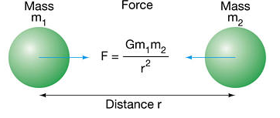

- A common error for students is to forget to square the radius.

- Henry Cavendish conducted various experiments to measure the value of G.

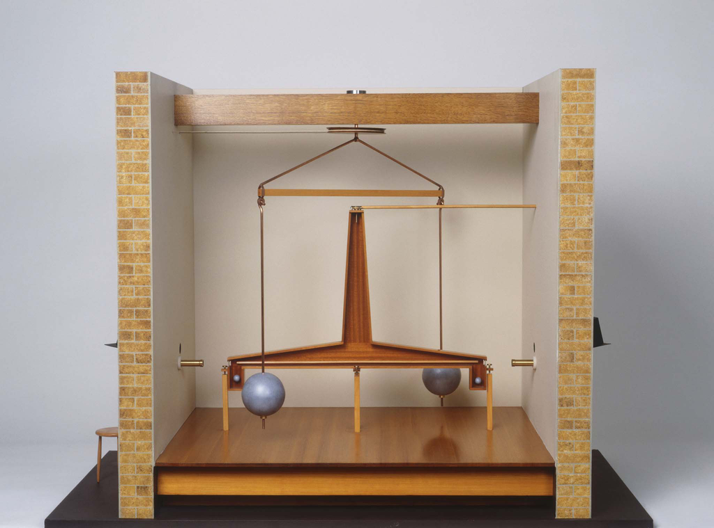
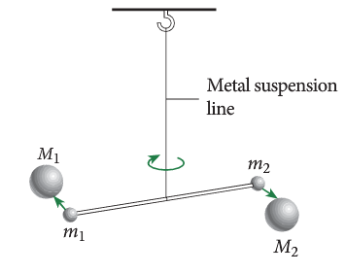

- The force of gravitational attraction is mutual. That is, the size of the force that is exerted by the Earth on a person is the same size as the force that the person exerts on the Earth.

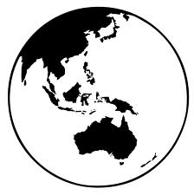
~700 N
~700 N
- If the person was to jump a metre off the ground, the Earth will attract the person back with the same force that the person attracts the Earth. This force will be ~700 N (depending on the person’s mass).

- The acceleration of the person towards the Earth will be ~10 ms⁻². The acceleration of the Earth towards the person will be ~0 ms⁻² (due to the huge mass of the Earth).

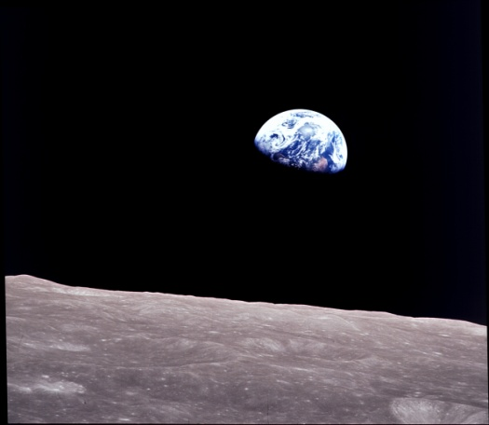
- The mass of the Earth is 6.00 x 10²⁴ kg. If the centres of the Earth and moon are 3.90 x 10⁸ m apart, the gravitational force between them is about 1.90 x 10²⁰ N. What is the approximate mass of the moon.

- Calculate the force of attraction between you and your nearest neighbour. List your assumptions.

- When dealing with estimation questions, make reasonable estimates. Estimate your friend’s mass as 60 kg or 65 but not 64.5 kg – too accurate for an estimate. Use 1 or 2 SF in the answer.

Objects with mass produce a gravitational field in the space that surrounds them; field theory attributes the gravitational force on an object to the presence of a gravitational field.
This includes applying the relationship

Gravitational Field

- A field can be described as an area in which an object will experience a force.

- Gravitational fields are regions in which a mass will experience a force.
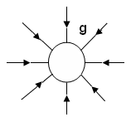
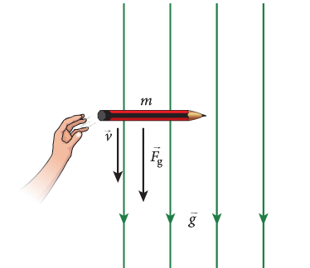
- The diagram to the right shows the radial gravitational field distribution around an object, for example, the Earth.

- Gravitational forces are vector quantities and can be represented by vector arrows.
- The arrow shows that the direction of the gravitational force is towards the object.
- The more arrows, the greater the mass of the object and therefore the greater the gravitational field.
- The closeness of the arrows indicates the size of the field at any point within the field.

- Most fields obey the “inverse square rule” which is that the force is proportional to the inverse of the distance squared:

. $F ∝ \frac{1}{r^{2}}$ Gravitational fields are no different.

- Consider the two field diagrams that represent the gravitational fields around two planets O and P which have the same radius. X represents a mass which is exactly the same distance above the planets.
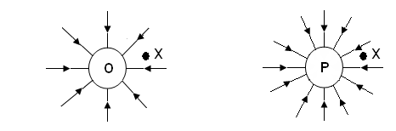

Which of the following statements is true? Where the statement is false, write in a correct
answer. If true, justify your answer.

- The planets have the same radius so must have the same acceleration due to gravity at the surface of the planets.

- The gravitational force is weaker on mass ‘X’ above planet P.

- The mass of planet O is less than the mass of planet P.

- The force of attraction between two objects is a mutual attraction
.
- A person standing on the surface of the Earth is pulled down to the Earth. The Earth is also pulled towards the person.
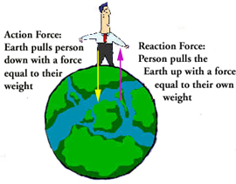

- The force that the Earth exerts on the man can be calculated by

- If the mass of the man is 85.0 kg, calculate the force of attraction from the Earth.

- According to Newton’s Second Law, the net force acting on the person will be F = ma.

- To calculate the acceleration, $a= \frac{F}{m}$ .

- Calculate the acceleration of the person in the situation above.

- It is obvious that this acceleration is g, acceleration due to gravity – 9.80 ms⁻².

- The force that the person exerts on the Earth is equal to his weight.

- Calculate the acceleration of the Earth in the situation above.

Work and energy
When a mass moves or is moved from one point to another in a gravitational field and its potential energy changes, work is done on the mass by the field.
This includes applying the relationships

- Work is done when a force is used to move an object a certain distance.

Work = force x displacement
W = Fs

- The unit of work is the joule (J). One joule of work is done if a force of 1 Newton moves an object through a displacement of 1 metre in the direction of the force.

- Two boys are using a force of 1.00 x 10² N to move a bed 3.00 m across a bedroom. What is the work done?

- If an object is moved vertically it is influenced by a gravitational force.

Work = force x displacement
W = Fs F = mg
W = mgs

- Work and energy are related. This work is equal to the gain in potential energy when an object is lifted above the ground.
W = mgs
E_{p} = mgh

- What work is required to lift a 5.00 kg bag of potatoes from the floor to a shelf 1.50 m above the ground?

Energy
- Energy can be defined as the ability or capacity to do work. Whenever work is done, some energy is transferred from one object to another.
- The unit of energy is the same as that of work, namely the joule (J).

Kinetic Energy
E_{k} = ½ mv² E_{k} = kinetic energy (J)
m = mass (kg)
v = velocity (ms⁻¹)

A man is running at 5.00 ms¹ and using 937 J of energy, what is his mass?

Gravitational Potential Energy

E_{p} = mgh E_{p} = potential energy (J)
m = mass (kg)
g = acceleration due to gravity (ms⁻²)
h = height above earth (m)

- A ball is thrown into the air. Just before it starts its downward journey (velocity equal to zero) it is at a height of 2.50 m above the ground. If it has a mass of 0.500 kg, what is its potential energy?

Law Of Conservation Of Energy

- Energy is neither created nor destroyed, but can be readily converted from one form to another.

Energy Transformations Between Kinetic And Potential Energy

E_{p lost} = E_{k gained}
mgh = ½ mv² masses cancel so
gh = ½ v²
- A girl is on a diving board 3.00 m above the water below. With what velocity will she hit the water when she dives?

- A 200 g box is at rest at the top of a hill. Assuming that there is no friction calculate
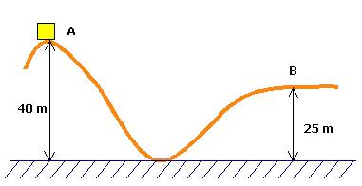
- the potential energy at A.
- the kinetic energy at the bottom of the hill.
- the velocity of the box at B.

- Newton’s Law of Gravitation can be modified to calculate the energy required to put a satellite into orbit.
$W=F s= \frac{G m_{1}m_{2}}{r^{2}} x r= \frac{G m_{1}m_{2}}{r}$ s = r

- As an object moves towards the Earth, its gravitational potential energy will decrease as it is converted into kinetic energy
- The change in E_{P} is equal to the work done.
$W=ΔE_{P}= \frac{G m_{1}m_{2}}{r_{1}}- \frac{G m_{1}m_{2}}{r_{2}}= G m_{1}m_{2}[\frac{1}{r_{1}}- \frac{1}{r_{2}}]$

    - A stationary object in space is located at a distance of 10 000 km from the centre of a certain planet. It is found that 1.00 MJ of work needs to be done to move the object to a stationary point 20 000 km from the centre of the planet. Calculate how much extra work needs to be done to now move the object to a stationary point 80 000 km from the centre of the planet.

Escape velocity

- The escape velocity is the minimum velocity required to leave a planet or moon. For a rocket or other object to leave a planet, it must overcome the pull of gravity.
- The velocity can be calculated from
$$v= \sqrt{\frac{2 G M}{r}}$$

where G = Universal gravitational constant
M = mass of planet or moon (kg)
r = radius of of planet or moon (m)

- Calculate the speed required for an object to ‘escape’ from Earth.
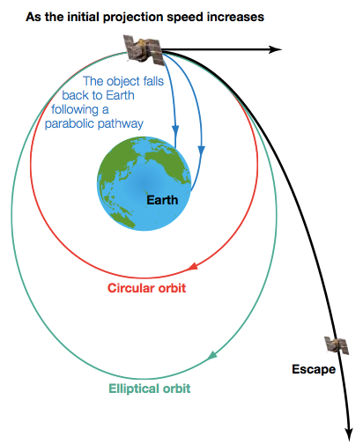

Gravitational field strength is defined as the net force per unit mass at a particular point in the field.
This includes applying the relationships

Calculating Gravitational Field Strength

- The force that causes an object to fall towards Earth is the gravitational force between that object and the Earth, otherwise known as weight. The weight follows the Universal Gravitational Laws hence:

where m_{E} = mass of Earth and m_{o} = mass of object

Now weight = mass of object x gravity or wt = m_{s}g
So
M_{o} cancels out on each side so;

- NOTE:
- This implies that the value of “g” is independent of the mass of the object.
- Therefore, all objects fall at the same rate, regardless of mass
- For any object on the Earth’s surface, G, m_{E}, and r are constant so ‘g’ is the same value.
- In reality, the Earth bulges at the poles as it is spinning fast. The radius at the equator is slightly larger, so ‘g’ will be slightly less at the equator (9.78 ms⁻¹) and more at the poles (9.83 ms⁻¹)
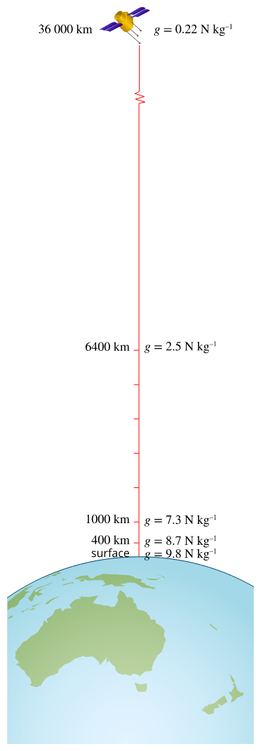
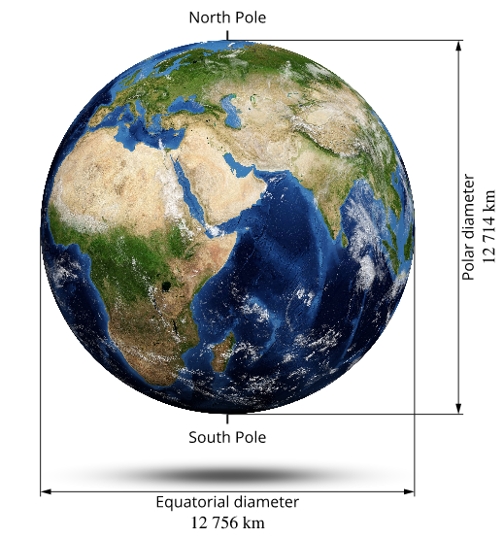

The Earth is a flattened sphere, which means its gravitational field
is slightly stronger at the poles.

The Earth's gravitational field strength is weaker at higher altitudes.
- Determine the acceleration due to gravity on a rocket of mass 6.0 x 10³ kg when it is on the Earth and when it is in orbit 250 km above the Earth.

- Sometimes a value you are looking for is a constant and is found in your data sheet.
- Don’t forget to change km to m when dealing with distance above Earth and add to radius of Earth (or other large mass).

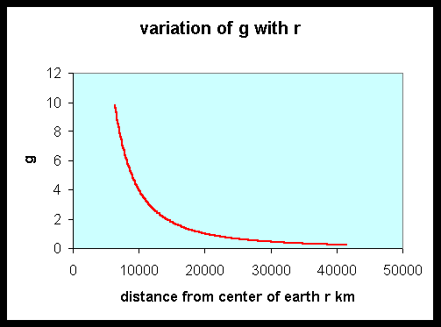
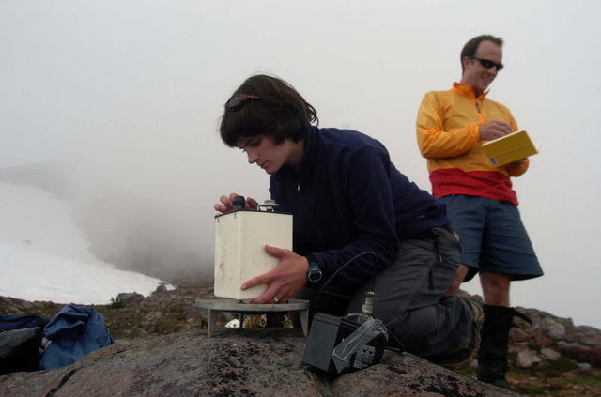

Gravimeter used to measure local gravitational fields.

- Find the approximate mass of the moon if ‘g’ on the moon is ~1/6 of ‘g’ on Earth and the radius of the moon is ~1/4 of the radius of the Earth.

The vector nature of the gravitational force can be used to analyse motion on inclined planes by considering the components of the gravitational force (that is, weight) parallel and perpendicular to the plane.

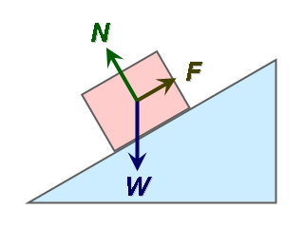
Vector Components

- Just as two vectors can be added, a single vector can be split into two parts or components.

- It is often useful to deal with two components which are mutually perpendicular, since they cannot influence each other. (E.g. moving north cannot have any effect on how far east you are.)

- Two components must of course add up to give you the original vector.
e.g. A car drives NW at 65 kmhr⁻¹. At what velocity is the car moving
(a) northwards & (b) westwards?

component
north 65 kmhr⁻¹

component
west

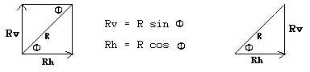
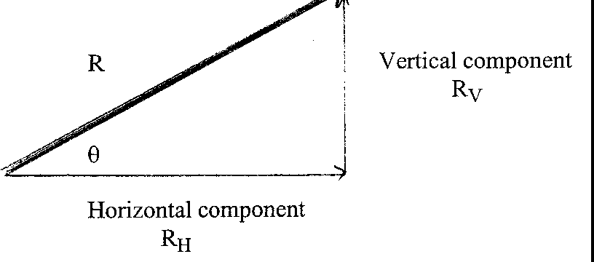
- A vector can be resolved into a horizontal and a
θ
θ
θ
vertical component that are at right angles to
each other as shown in the diagram.

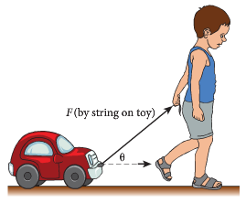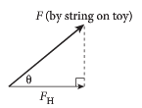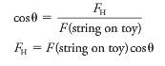

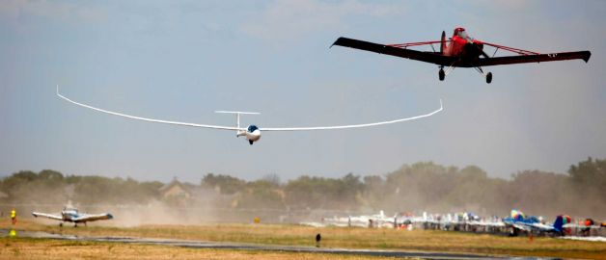
- A glider is being pulled by a plane to lift it into the air. The rope has a tension of 4.00 x 10³ N and makes an angle of 30.0º to the ground. Find the horizontal and vertical components of the force.
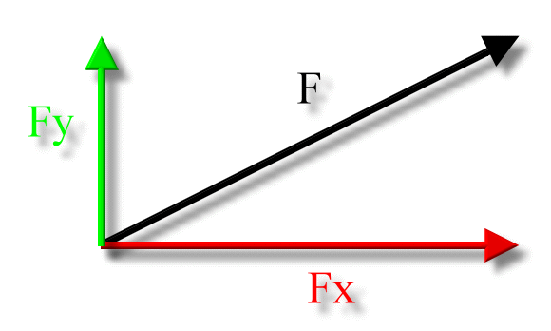
30°
4000 N

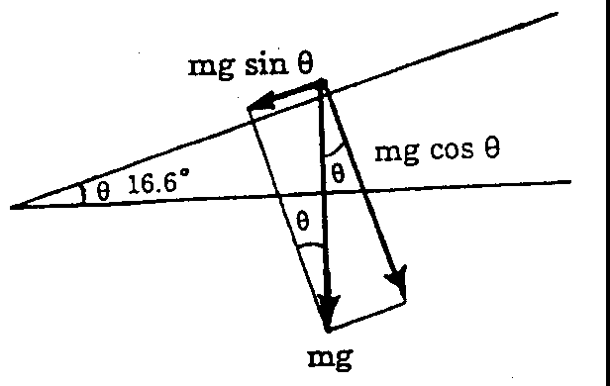

Objects on a slope.

- Component parallel to plane = mg sinθ

- Component perpendicular to plane = mg cosθ

- If the force down the slope is mg sinθ, then the acceleration down the slope will be g sinθ.
- If an object is released down a frictionless slope with an initial velocity of 0, down a distance of s meters and takes t seconds, then g can be calculated by
$$g= \frac{2 s }{t^{2}sinθ}$$

Inclined planes

- A car travelling along a horizontal surface at a constant speed has all of its forces balanced. The forces up will equal the forces down.
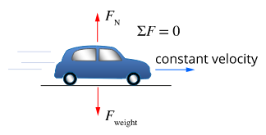

- If the car were to roll down a hill, the forces are no longer balanced and the car will accelerate.
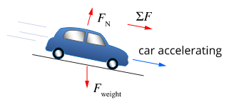

- The size of the overall force can be determined by finding the components of the weight force that are parallel and perpendicular to the plane. This is on a smooth slope.
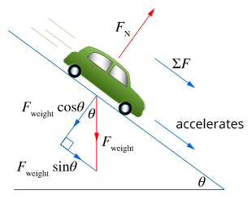

- In reality, friction is usually involved. If a car rolls down a hill at constant speed, all of the forces must be balanced.
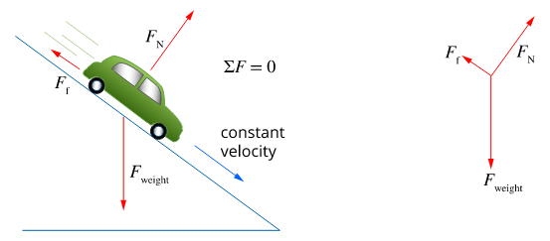

- A skier of mass 50 kg is skiing down an icy slope that is inclined at 20° to the horizontal. Assume that friction and drag are negligible.

- Determine the component of the weight perpendicular to the incline.
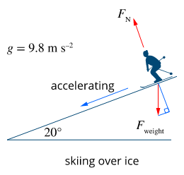

- Determine the component of the weight parallel to the incline.

- Determine the acceleration of the skier.

- A block of mass m₂ = 43.8 kg on a smooth inclined plane of angle 30° is connected by a cord over a small frictionless pulley to a second block of mass m₁ = 29.2 kg hanging vertically.

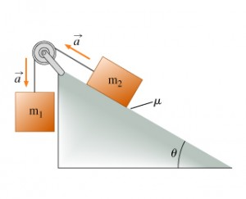
- What is the acceleration of each body?

- What is the tension in the cord?

Projectile motion can be analysed quantitatively by treating the horizontal and vertical components of the motion independently
This includes applying the relationships

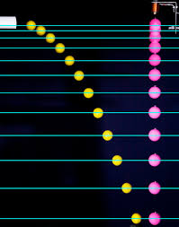
Flying through the air

Projectiles In General

- A projectile is something that is launched into the air such that it lands a distance from where it started.

- The stroboscopic photograph shows the motion of two balls. One is projected horizontally while the other is dropped vertically. At any instant, the two balls are at the same level.

- Their initial vertical velocities are zero and their vertical accelerations (due to gravity) are equal – both 9.8 ms⁻² downwards.

- Thus the projectile falls like a body that is dropped from rest.
- Its horizontal velocity does not affect its vertical motion.

- The horizontal and vertical motions of an object are independent and can be treated separately.

- Horizontal Motion – this is assumed to be constant during the flight of the projectile. There is no horizontal acceleration, a = 0. This motion can be used to determine the range of the flight (horizontal distance travelled).

- Vertical Motion – the body is under the influence of gravity with a constant downward acceleration of 9.80 ms⁻². This motion can be used to determine time of flight and maximum height.

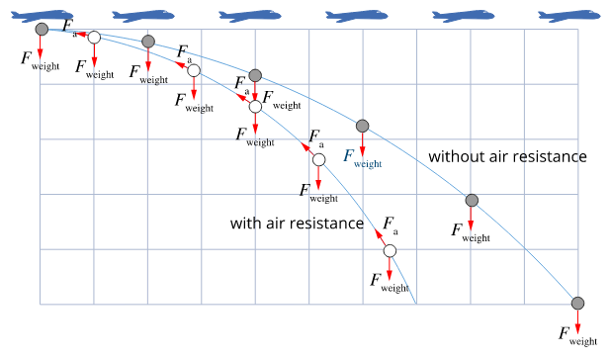

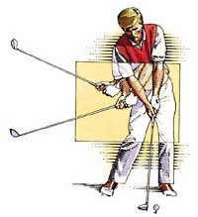
Horizontal projectiles
      - Consider a golfer hitting a ball off a cliff. Assume the ball is struck such that its initial path is parallel to the ground, i.e. no vertical component to the motion.

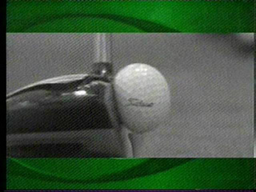
      - At the moment of impact a force is acting on the ball to deform it. The forces acting on the ball are shown.
mg
F_{N}
F_{club}

- Once the ball is in flight the only forces acting on it are gravity and air resistance.

If air resistance is ignored, there is only one force – gravity.
velocity
(not a force)
velocity
(not a force)

mg
air resistance


mg

nett force

nett force

- Because only the weight force is acting here, the ball will accelerate downward at “g” (9.8 ms⁻²) while at the same time, continue to move horizontally. Two motions happen simultaneously, one not affecting the other.

- Further, the horizontal velocity remains constant because there is no horizontal force acting (ignoring friction with the air).

- The motion of the golf ball after it has been hit is shown.

- The horizontal component of the velocity remains the same. There is no force in the horizontal direction (since friction has been ignored) and, therefore, there is no acceleration in the horizontal direction.

- can be used to solve problems.

- The vertical component is getting bigger due to acceleration in this direction, g. Each vertical component would be the same as an object dropped straight down.

- Equations involving acceleration can be used to solve problems.

- These lines represent the component of the velocity at that point – not the force acting on it.

- A rock is thrown outward from a very high cliff at 25 ms⁻¹. Plot its path.

After 1 second:
horizontal displacement
vertical displacement down (s)

Complete the table.
 | Start | 1 sec | 2 sec | 3 sec | 4 sec | 5 sec
Vertical displacement (m) | 0 | 4.9
Horizontal displacement (m) | 0 | 25

Plot this data below.
Object Trajectory after thrown Horizontally at 25ms⁻¹
10 20 30 40 50 60 70 80 90 100 110 120 130
VERTICAL DISPLACEMENT
0

20

40

60

80

100

120

140

HORIZONTAL DISPLACEMENT

- The resulting parabola represents the path taken by the rock.
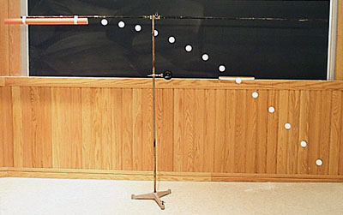
            - This is a multiflash image of a ball which is propelled horizontally.

            - Note that horizontal displacement forward stays about the same, while vertical displacement increases with each frame.

Resultant Velocity (“overall velocity”)

- At any instant the resultant velocity can be found by adding the horizontal velocity vector to the vertical velocity vector at this point, using vector addition.

- Find the resultant velocity at t = 1.0 seconds. (Fill in missing calculations)

Setup diagram: Addition diagram:

25 ms⁻¹

9.8ms⁻¹ Resultant

- The time it takes to fall vertically is the same time it takes to move horizontally.

Tips for problems involving projectile motion

- Draw a diagram.
- Write out the information for the horizontal component and the vertical component.
- Horizontally, $↔$ velocity, v, is constant – only need $v=\frac{s}{t}$ .
- The horizontal component is always the same throughout the flight.
- Vertically, $↕$ the projectile is moving at a constant acceleration, 9.8 ms⁻² downwards.
- Use $v=u+at, s=ut+ \frac{1}{2}at^{2}, v^{2}= u^{2}+2as$.
- IMPORTANT: clearly specify whether up or down is positive – keep this consistent.
- The vertical component will decrease on the way up (deceleration) and increase on the way down (acceleration).
- The speed at any point is a vector addition of the horizontal and vertical component – use Pythagoras to determine the speed.
- If velocity is required, a direction is needed (normally with respect to the horizontal).

- A revolver is fired horizontally, 1.50 m above the ground with a muzzle velocity of 650 ms⁻¹.
(a) What is the vertical component of the velocity of the bullet when it lands?
(b) How long does it take to strike the ground?
(c) How far away from the revolver does it strike the ground (range)?

- A boy throws a rock into the sea with a horizontal velocity of 5.00 ms⁻¹. The height of the cliff is 49.0 m and the rock is thrown 1.00 m above the top of the cliff. How far from the face of the cliff did the rock land?

- A boy jumps horizontally from a diving tower 1.00 m above the water and lands 2.50 m away from the edge of the tower.

- How long was he in the air?
- What was his horizontal take-off velocity?

- Two thugs heave a body horizontally off a 60.0 m high cliff top at 1.20 ms⁻¹, hoping that it will land in bushes 5.00 m from the base of the cliff. Determine if they succeed and if not, how far away from the bush does the body land.

- A much harder question!
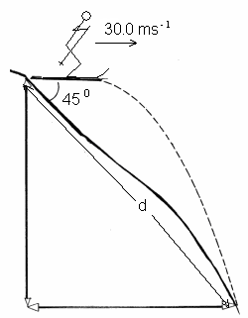
A ski jumper competing in the winter Olympics travels down a slope and leaves the ski track moving in the horizontal direction with a speed of 30.0 m s⁻¹. The landing incline below the take off point slopes downwards at 45º to the horizontal. (Assume no air resistance or friction.)

- If the skier lands on the slope, calculate the skier’s displacement down the slope.
- How long is the skier in the air before landing?
- What is the vertical component of velocity just before the instant the skier lands?

- Since energy must be conserved, it is possible to calculate values using changes in kinetic and potential energies.

- A ball of mass 500 g is tossed horizontally at 5.00 ms⁻¹ from a height of 1.50 m. What is the speed of the ball as it lands? Ignore air resistance and answer to the correct number of sf.

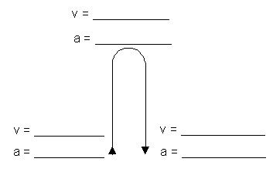
Vertical projectiles
- A ball is thrown into the air at 5.0 ms⁻¹ and then returns to
the same height it was thrown from.
Complete the following diagram to show the velocity and
acceleration at the start, middle and end of the throw
assuming no air resistance.

- All objects will fall to Earth regardless of their size and mass (assuming no air resistance) at 9.8 ms⁻² due to the pull of gravity.

- If an object is thrown into the air, it will take the same time to reach the top, as it will to return to its starting position. Newton’s equations of motion can be used to solve vertical projectile problems.

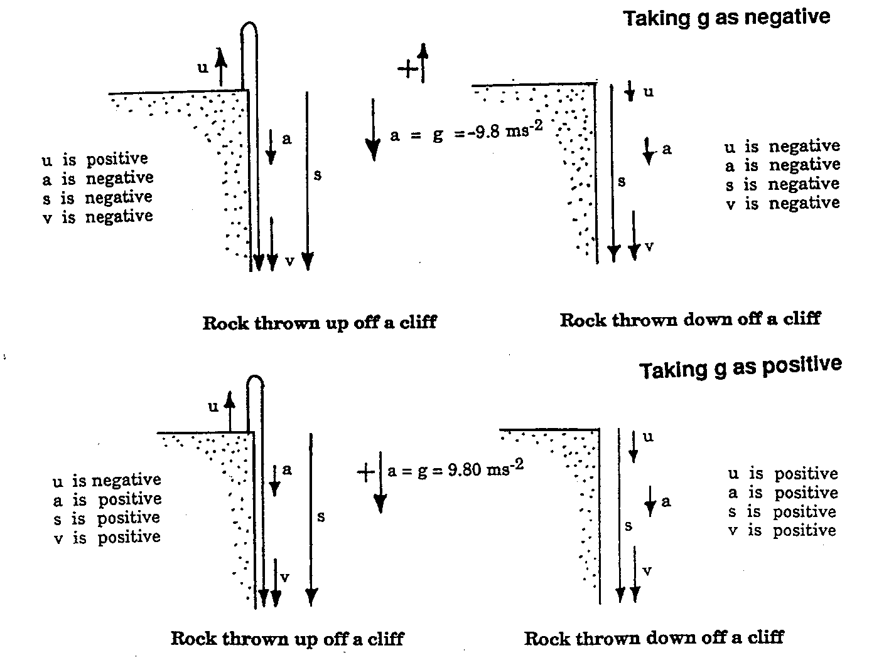
- When an object moves up and down, when dealing with displacement, velocity and acceleration, a direction must be indicted. Choose one direction as positive then values in the other direction must be negative.

Choosing a sign convention

- When doing these calculations it is important to remember that vectors acting in opposite directions must have opposite signs.

- During a car accident a piece of the car is projected vertically upwards from the ground with an initial velocity of 20.0 ms⁻¹. Neglecting air resistance find

- maximum height the piece reaches (b) total time in the air after returning
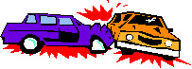
℘

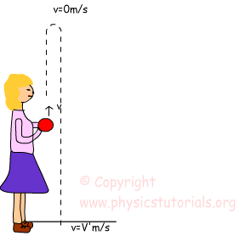
- A ball, which is held 1.20 m above the ground, is thrown into the air at 3.50 ms⁻¹ then returns to hit the ground.

- With what velocity will it hit the ground? (b) How long is it in the air?

(c) How far horizontally did the ball travel?

- A kangaroo jumps to a vertical height of 2.80 m. How long was it in the air before returning to earth?

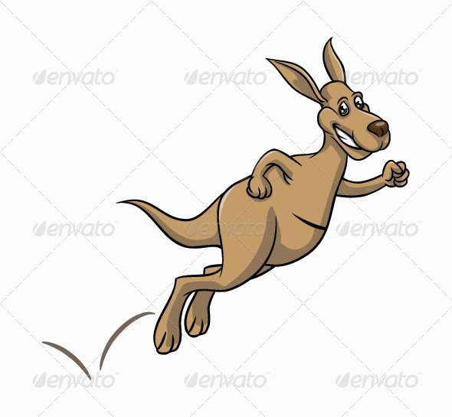

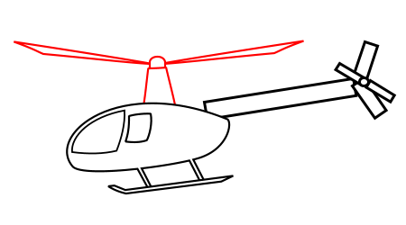
- A helicopter is ascending vertically with a velocity of 6.00 ms⁻¹. At a height of 1.20 x 10² m above the earth, a package is dropped from a window. How much time does it take for the package to reach the ground?

- A toy rocket is fired vertically upwards from the ground at an initial velocity of 20.0 ms⁻¹.

- How fast is it moving when it reaches a height of 16.0 m on the way up?

- How long is required to reach this height?

- A stone is thrown vertically upwards with an initial velocity of 10.0 ms⁻¹ from the edge of a cliff 65.0 m high.

- What is its velocity just before hitting the ground below?

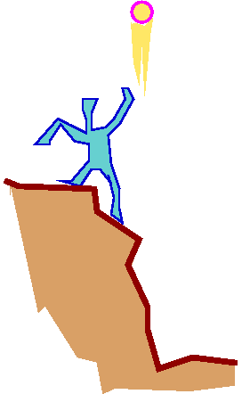

- How much later does it reach the bottom of the cliff?

Oblique Projectiles
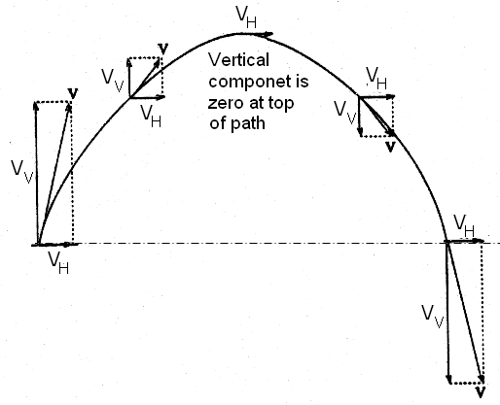
- These are projectiles where the initial velocity is not horizontal or vertical to the ground but is at some angle e.g. an athlete doing the high jump.

- As the diagrams shows, projectile motion consists of

- a horizontal component with constant velocity (unchanged throughout flight)
- a vertical component with constant downward acceleration (9.8 ms⁻²)

- The combination of these two components produces the characteristic curve associated with projectile motion.

http://www.compadre.org/Physlets/mechanics/illustration3_4.cfm


Taking off and landing at the same point

- The path of an oblique projectile is a parabolic curve (if no air resistance)

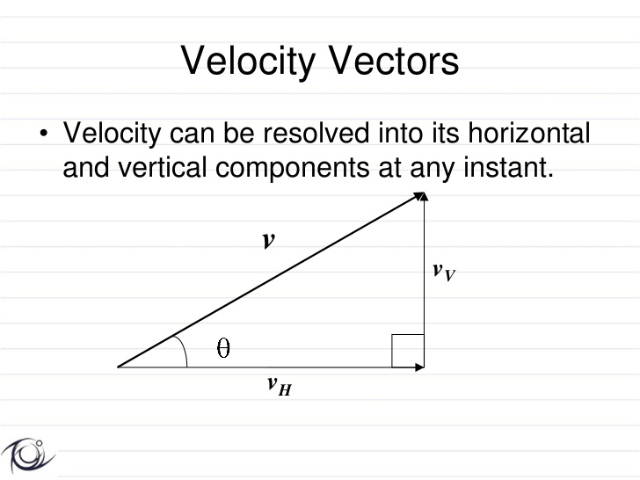
- Initial velocity has vertical and horizontal components:

vertical velocity v_{V} = v sin θ
horizontal velocity v_{H} = v cos θ

- Range is the horizontal displacement and the flight is the path the projectile takes.

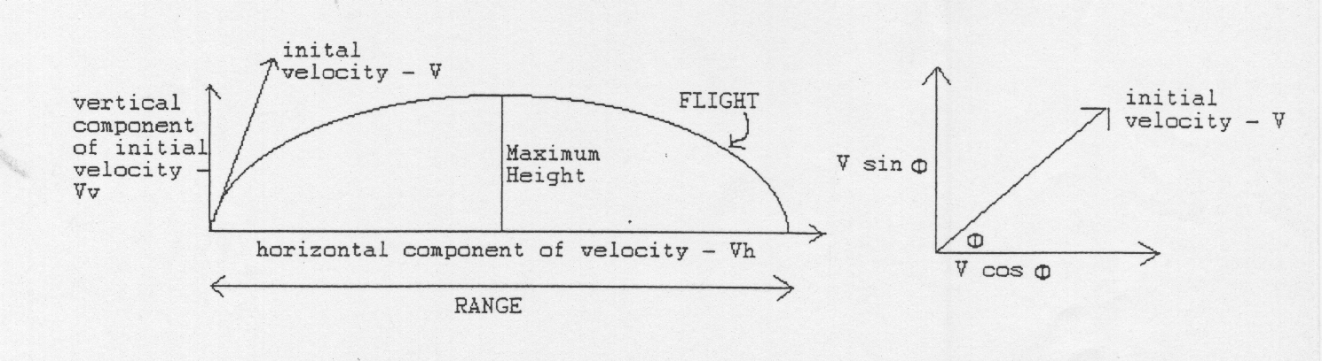
θ
θ
θ

- If the object lands at the same height that it takes off from, then the maximum range occurs when initial velocity is at 45°. However, depending on situation, e.g. air resistance, height above ground and other factors, other angles can be preferred.
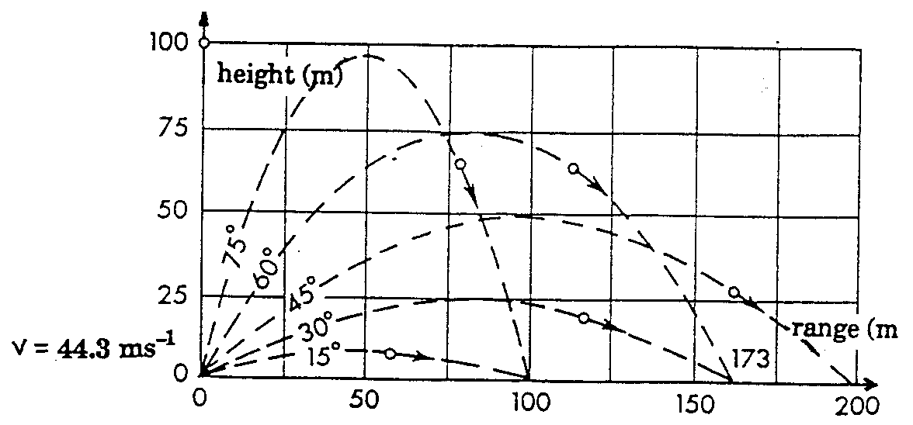

- Horizontal component is constant (if no air resistance) and depends only on initial horizontal velocity.

- Vertical component decreases to top of flight (where it is zero) then increases to bottom of flight. If take off and landing at same height, initial and final velocities are the same. Vertical component depends on both initial velocity and acceleration due to gravity.

- Direction is important for displacement, velocity and acceleration. Use one direction as positive and one as negative – your teacher will mostly use down as positive (as gravity always acts down).

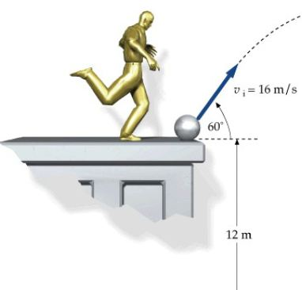
CONSIDER HORIZONTAL AND VERTICAL MOTION SEPARATELY.

Example
A ball is kicked off the ground with a velocity of 36.0 ms⁻¹ into the air at an
elevation of 25° above the horizontal. Find the height the ball reached and
the distance it landed from the kicker.

STEP 1: Usually the first step is to resolve the velocity in horizontal and vertical components.
up = -ve
v
vertical component, v_{v} = -36 sin25° = -15.21 ms⁻¹
v_{V}
horizontal component, v_{H} = 36 cos25° = 32.63 ms⁻¹
25°
v_{H}

STEP 2: Find the maximum height reached when v_{V} = 0.

A projectile fired straight up at 15.21 ms⁻¹ will reach the same height as a projectile fired at 36 ms⁻¹ at an angle of 25°.

height
36 ms⁻¹
15.21 ms⁻¹

25°

Using vertical data only:
u = v_{V} = –15.21 ms⁻¹ (up is –ve)
a = g = 9.8 ms⁻²
v = 0 ms⁻¹
s = ?
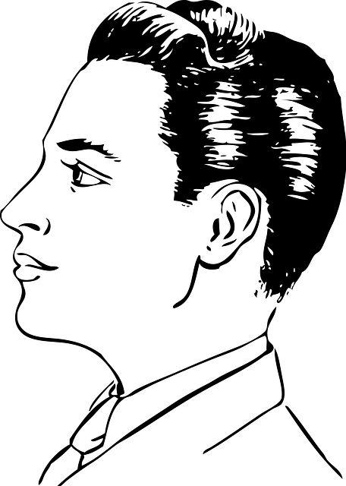
A person viewing the kick from the side, at a distance, will not see
the ball go at an angle. Rather, they will see the ball go straight up
at 15.21 ms⁻¹, reach a height of 11.80 m then return to the ground.

STEP 3: Find the time to strike the ground using the vertical component.

The time taken for a projectile thrown straight up with a velocity of 15.21 ms⁻¹ to reach the ground will be the same time taken for a projectile thrown at an angle of 25° at a velocity of 36 ms⁻¹ to reach the ground.
v = 0
t = v - u
a
t = 1.55 s
x 2 = 3.10 s

u = -15.21
u = v_{V} = –15.21 ms⁻¹ (up is –ve)
v = +15.21 ms⁻¹
a = g = 9.8 ms⁻²
t = ?

STEP 4 : Find the range of the ball. This is determined from the time of flight and the horizontal component of the velocity – a constant 32.63 ms⁻¹.

A projectile fired straight out at 32.63 ms⁻¹ will cover the same distance as a projectile fired at 36 ms⁻¹ at an angle of 25°.
u = v_{H} = 32.63 ms⁻¹
a = 0 no horizontal acceleration
t = 1.55 s
s = ?


A person viewing the kick from above, at a distance, will not see
the ball go at an angle. Rather, they will see the ball go straight
across at 32.63 ms⁻¹ and cover a distance of 50.60m.

- An archer fires an arrow at 20.0 ms⁻¹ into the air at an angle of 40.0° to the horizontal.

- How long was it in the air before it hit the target which was at the same height as the arrow was fired?

- How far did it travel before hitting the target at the same height it was fired from?

- Bruce kicks a ball at an angle of 30.0⁰ from the horizontal with an initial speed of 15.0 ms⁻¹. Find how far the ball travels horizontally before hitting the ground.

Taking off and landing at different points

- Often, the point of release of the projectile is not the same as the landing point. For example, a basketball shot or a shot put throw.
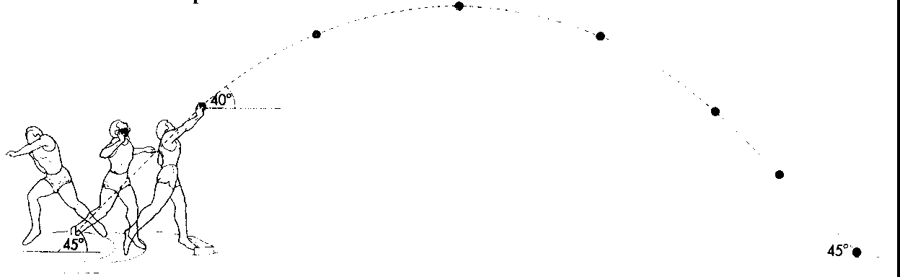
- 45º is the optimum angle when the points of release and landing are the same. In track and field this is seldom the case. For example, a shot putter can release the shot from about 2m above the ground.

- There are four factors that will influence the distance a projectile will travel:
- the original speed of the projectile,
- angle of projection to the horizontal,
- acceleration due to gravity,
- height of projection (vertical distance from point of release to point of landing).

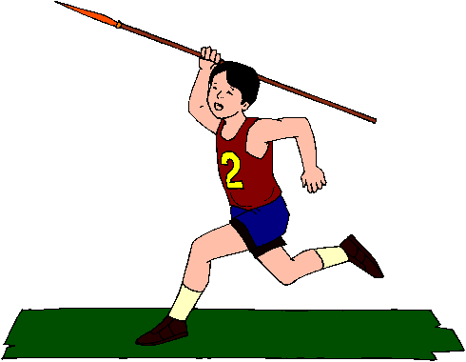
- Example
A javelin is hurled at 42 ms⁻¹ into the air at an elevation of 35° from a height of 1.85m.
How high will it travel and how far away does it land?

STEP 1: Resolve the velocity in horizontal and vertical components.
v
v_{V}
vertical component, v_{v} = 42 sin35° = 24.1 ms⁻¹
35°
horizontal component, v_{H} = 42 cos35° = 34.4 ms⁻¹
v_{H}

STEP 2: Find the time to strike the ground using the vertical component.

The time taken for a projectile thrown straight up with a velocity of 24.1 ms⁻¹ to reach the ground will be the same time taken for a projectile thrown at an angle of 35° at a velocity of 42 ms⁻¹ to reach the ground.

24.1 ms⁻¹
42 ms⁻¹

35°

Using vertical data only:
u = v_{V} = –24.1 ms⁻¹ (up is –ve)
a = g = 9.8 ms⁻²
s = 1.85 m

STEP 3: Find the maximum height reached when v_{V} = 0.
u = v_{V} = –24.1 ms⁻¹ (up is –ve)
a = g = 9.8 ms⁻²
v = 0 ms⁻¹
s = ?

A person viewing the throw from the side, at a distance,

will not see the javelin go at an angle. Rather, they will
see it go straight up at 24.1 ms⁻¹, reach a height of 41.9 m
then return to the ground.

STEP 4 : Find the range of the javelin. This is determined from the time of flight and the horizontal component of the velocity – a constant 34.4 ms⁻¹.
u = v_{H} = 34.4 ms⁻¹
a = 0 no horizontal acceleration
t = 4.99 s
s = ?


A person viewing the throw from above, at a distance, will not see the javelin go at
an angle. Rather, they will see it go straight across at 34.4 ms⁻¹ and cover 172 m
before it hit the ground.
- An archer fires an arrow at an angle of 35.0°. to the horizontal with an initial velocity of 25.0 ms⁻¹. If the arrow is 1.30 m above the ground when fired, how far from the archer will it hit the ground?

- An archer fires an arrow at 35.0 ms⁻¹ horizontal to the ground. If it lands 17.3 m away,
  - how high was the arrow above the ground?
  - at what velocity and angle did the arrow hit the ground?

- A cricket ball is thrown at an angle of 20.0⁰ to the horizontal and reaches a maximum height of 15.0 m above its release point. How fast was it thrown?

- A stuntman is planning a stunt. A car is to take off from a ramp, which is angled at 15.0⁰ to the horizontal to land on another ramp also angled at 15.0⁰ to the horizontal (in the opposite direction), in-between the two ramps are a number of cars. The car’s maximum take-off velocity is 90.0 kmh⁻¹ which it can reach as it starts up the first ramp. The distance between the end of the first ramp and the start of the second ramp is exactly 32.0 m. (Assume no friction between car and ramps). Using your knowledge of projectiles, calculate if the stunt is safe to do.

- A high jumper leaves the ground at an angle of 70.0⁰ to the horizontal and clears the bar, which is set at just below 1.55 m. She then lands on a mat which is 0.500 m above the ground on the other side of the bar.
- What is the size of the vertical velocity the jumper must have to just clear the bar?

- How long is the high jumper in the air?

Tougher exam questions!

- A physics student observes a stone of mass 450 g being catapulted from the top of a cliff. The launch position at the top of the cliff is 6.00 m above ground level. The stone lands 20.0 m in front of the launch position. The initial launch speed u is at an angle of 40.0° to the horizontal. You may ignore air resistance for the calculations.

6.00 m
20.0 m
Cliff
40°
Initial launch speed u

6.00 m

Calculate the initial launch speed u of the stone. You must show clear algebraic steps in your solution.

- Hint: the flight time for both the horizontal and vertical components of motion will be the same. Combine two equations involving u and t.

- The photograph shows a swimming pool toy that sprays water when the plunger is pressed into the barrel containing water. A boy, using the toy, sprays water vertically from a height of 1 m and counts the time from the last drop of water leaving the barrel to it hitting the ground and finds it to be 3 s.
Plunger Barrel

Estimate the angle at which the toy should be held if it is to be used to spray water from the
surface of a swimming pool onto a person 4 m away. Assume that air resistance is negligible and show all your workings.

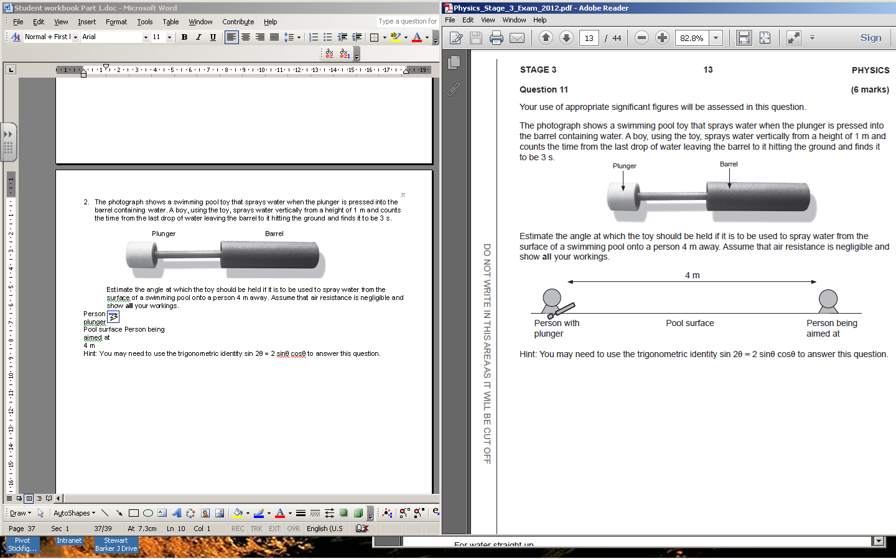

Hint: You may need to use the trigonometric identity sin 2θ = 2 sinθ cosθ to answer this question.

Applications
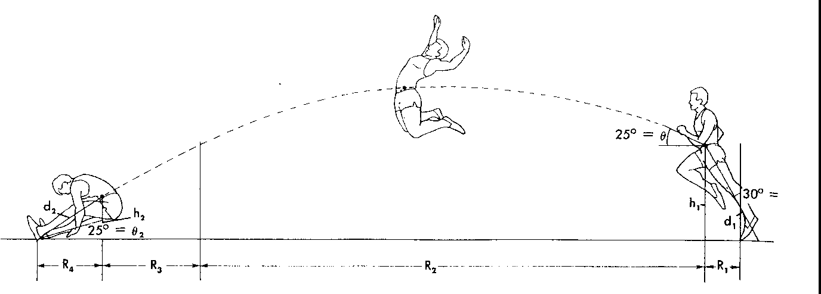
- Long Jump
- Centre of gravity follows a parabolic path.
- Legs do not.
- At end of jump, legs are thrust forward to gain distance. This creates a different angle of the legs at landing from take-off. This causes the C of G to fall below the level at take-off.
- Four ranges need to be considered during a long jump as shown above.
- Optimum angle for take off is less than 30º. This is because the athlete is trying to maximize horizontal velocity. This is done at the expense of vertical velocity. The higher the person tries to jump the slower they run. (Usually between 18º and 22º.)

Estimate how far a top class long jumper could jump.
⊕

- High Jump
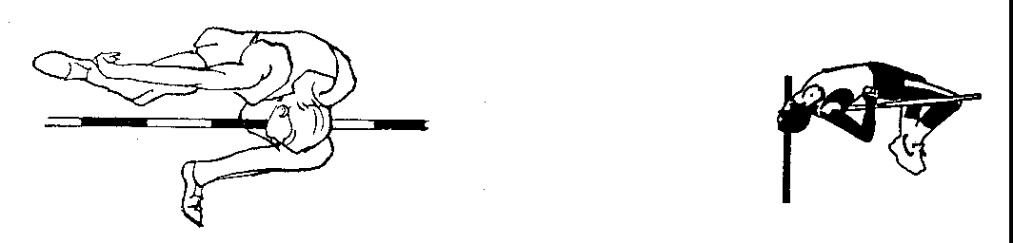
- The path of the C.O.M. is parabolic but vertical movement is stressed ie short and steep parabola.
- Style of jump can influence maximum height achieved. Lifting the C.O.M. by the minimum amount in order to clear the bar means less effort is required. ie the Fosbury Flop is preferred to other styles.

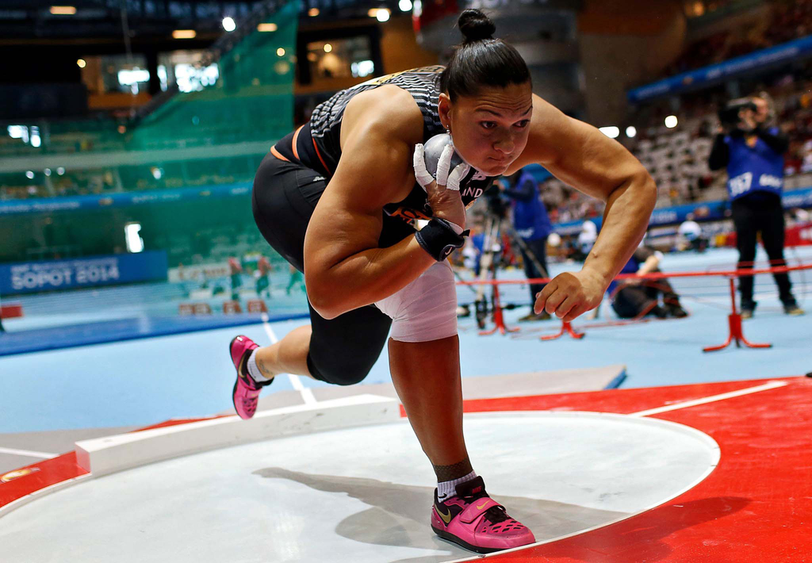
- Shot put
  - Advantage being tall – higher release height, longer range.
  - Ideal launch angle less than 45°, closer to 43°.
  - In reality, launching from this angle reduces speed of launch.
  - Ideal angle closer to 34°.

Air resistance

- As a projectile forces its way through the air it experiences a drag force (air resistance) which slows it down.
On the way down the net force is less.
On the way up the net force is more.
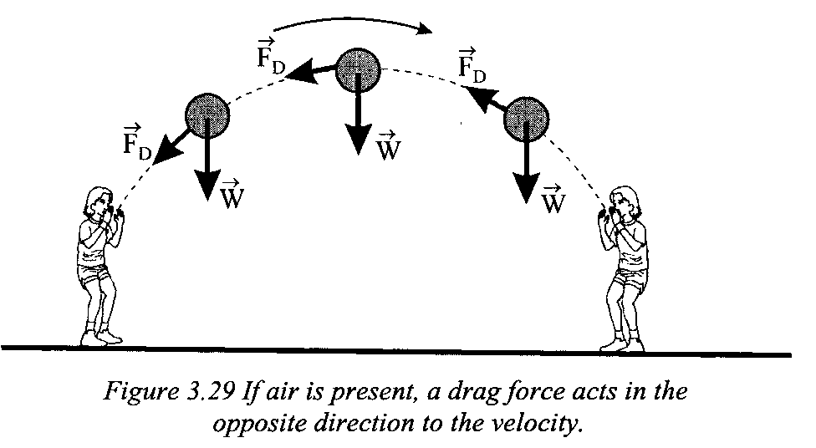

- The trajectory will differ from the ideal parabolic curve that would occur in a vacuum.

- Air resistance will have the following effects:
- reduce the range of the projectile,
- reduce the maximum height (maximum height is beyond the half way point),
- increase the angle of descent,
- speed of impact is less than launch speed,
- the projectile will take longer to come down than go up.

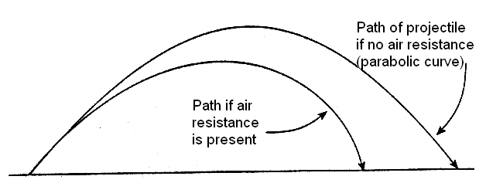

When an object experiences a net force of constant magnitude perpendicular to its velocity, it will undergo uniform circular motion, including circular motion on a horizontal plane and around a banked track; and vertical circular motion
This includes applying the relationships
Going Around In Circles
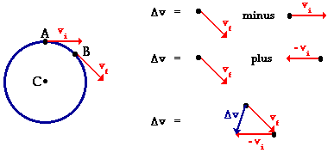
Going Around at a Constant Speed
- An object moving in a circle may travel with constant speed, but its velocity will be constantly changing because its direction of motion is constantly changing.

- Because the velocity is changing, the object will be accelerating. As there is acceleration there must be a net force acting to produce the circle motion.

Terminology and Equations:
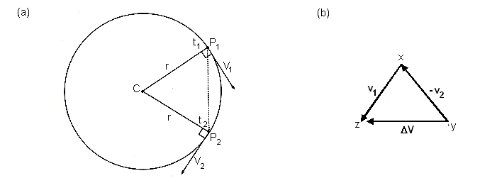
vector subtraction
Δv = v₂ – v₁
v₂
-v₁
θ
θ
a
F

- The radius (r) is a position vector acting out from the centre.
- The velocities (v₁ and v₂) are a tangent to the circle, and at right angles to the radius.
- Diagram (b) shows the change in velocity or acceleration (a).
- The acceleration is always towards the centre.
- The time (t) taken to move once around the circle is called the period (T).
- The frequency (f) can be found by 1/T.
- The distance travelled is the circumference of the circle (2πr) therefore
- From the above circles, the displacement from P₁ to P₂ could be calculated from v = st.
i.e. s = vΔt
r
r
vΔt
θ
This triangle is similar to the one above so,
- A student is swinging a yoyo in a horizontal circle 5.0 times each second. What is the period of the yoyo?

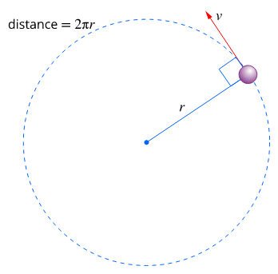
- You may feel like you are not moving but the earth takes one year to complete its revolution around the sun. Assuming it moves at a constant speed in a circle at a distance of 1.50 x 10⁸ km from the sun, at what speed does the earth travel in kms⁻¹.

- How fast is a person travelling on the Earth’s surface at the equator? The Earth completes one revolution in 24 hours and the radius at the equator is 6.4 x 10⁶ m.

Equations for acceleration:
- Equation for centripetal acceleration is
- Using main equation and substituting in other equations for v and r, two other equation can be found.

a_{c} = v² a_{c} = 4π²r a_{c} = 2πv
r T² T
substitute v = 2πr substitute r = vT
T 2π

- A side show attraction is racing cars. Assuming that the track is circular and that a boy is driving a car at an average velocity of 20.0 kmh⁻¹, 3.00 m from the centre, what is the size of the acceleration to move around the track?
- Don’t forget to change to SI units.

Centripetal Force:
- As shown before, because acceleration occurs in circular motion, there must be a force acting and this must act along the direction of the acceleration e.g. towards the centre.

- This centre-seeking force is called the centripetal force. As the force and acceleration are in the same direction we can now call our acceleration the centripetal acceleration, a_{c}.

- We know from Newton’s Second Law that F = ma

- Now in the case of centripetal acceleration, a_{c} =

- Therefore F_{c} = which is the equation for the centripetal force

- Note also as v = then in addition, F_{c} =
ΣF = ma = mv²
r

- Annie rides her bicycle at a constant speed around a circular track of radius 50.0 m. She completes one revolution of the track each minute.

a. What is her speed? | b. What is the magnitude of the centripetal acceleration acting on the rider? | - If the rider and cycle have a combined mass of 70.0 kg, what is the size of the force causing the circular motion?

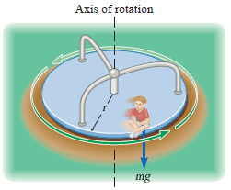
- A child is sitting 1.10 m from the centre of a merry-go-round and moves with a speed of 1.25 ms⁻¹. Calculate
  - the centripetal acceleration of the child

  - the net horizontal force exerted on the child (mass = 25.0 kg)


- A horizontal force of 210 N is applied to a 2.0 kg discus as it rotates uniformly in a horizontal circle (at arm’s length) of radius 0.90 m. What is the speed of the discus?

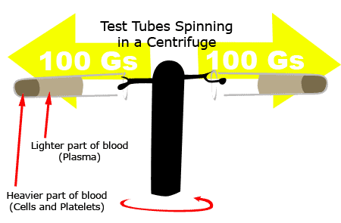
- How fast (in rpm) must a centrifuge rotate if a particle 9.00 cm from the axis of rotation is to experience an acceleration of 115 000 g’s?
115 000 g’s
115 000 g’s

Revisit Newton’s Laws
- When all the forces on an object are considered, we can apply the following formula.

ΣF = ma
R
Example 1

F_{w} = mg

- An object at rest – acceleration is 0. So, ΣF = 0.

- This means all the forces up = all the forces down, F_{w} = R

R

Example 2
F_{drag}
F_{thrust}

F_{w} = mg

- An object at constant velocity – acceleration is 0. So, ΣF = 0.

- This means all the forces up = all the forces down, F_{w} = R
and
all the forces left = all the forces right F_{drag} = F_{thrust}.

Example 3
F_{drag}
F_{thrust}

F_{w} = mg

- An object under constant acceleration. So, ΣF ≠ 0.
F_{net}
- The overall force is to the right, F_{net}.

- The object will accelerate to the right because of the net force.

ΣF = ma.

- When an object is undergoing circular motion, the centripetal force is the NET FORCE acting.

Centrifugal – An outward directing force?
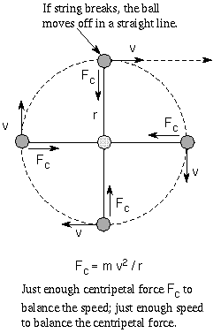
- Writers will often describe a centrifugal force or centre-fleeing force. “A centripetal force”, they say “acts towards the centre of the circle, so there must be a force acting away from the centre – we can feel it so it must exist.” IT DOES NOT!!

- Consider Newton’s First Law – objects will keep doing what they are doing unless acted upon by an external force. As the velocity of an object travelling in a circle is at a tangent to the circle so is the direction of travel.

- While the external force keeps acting, the object will keep travelling in a circle. If the external force is no longer available then the object will shoot off at a tangent to the circle NOT away from the centre.

- So although you may be able to feel a force acting away from the centre, for the reason above, physicists call it a “fictitious force” unlike the forces of gravity, etc.

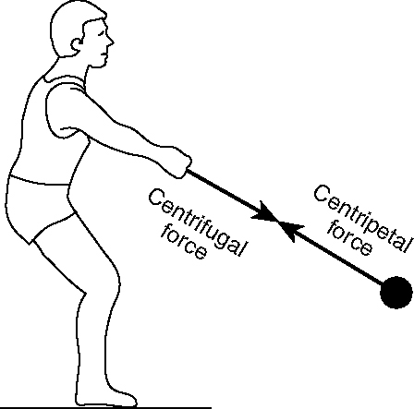
- Consider Newton’s Third law – for every action there is an equal and opposite reaction. An object in circular motion must have a force acting on it to keep it in circular motion.

- The source of the force must have a force acting on it due to the object.
This is the centrifugal force.

- The centripetal force acts on the object in circular motion – the centrifugal force
does not.

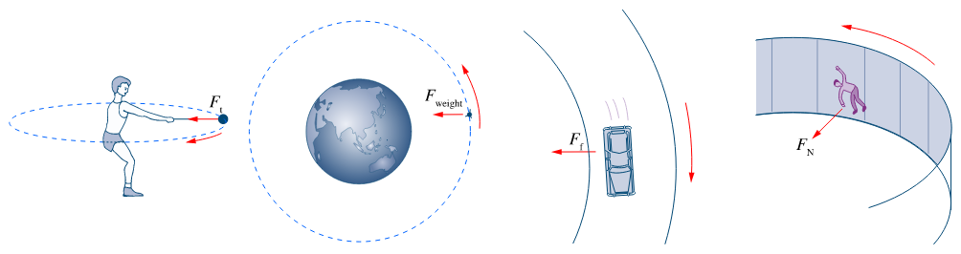
Centripetal Forces

- Examples of Centripetal forces are:
- Roller coasters. Force from the rail keep the roller coaster in circular motion

- Buses or cars suddenly turning a corner. Friction from the road on the tyres keep the car in circular motion.
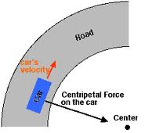
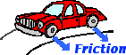

- Many sports such as hammer throwing. Tension in the rope keeps the hammer in circular motion.
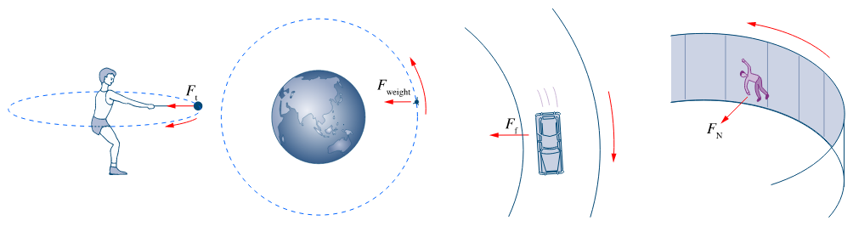
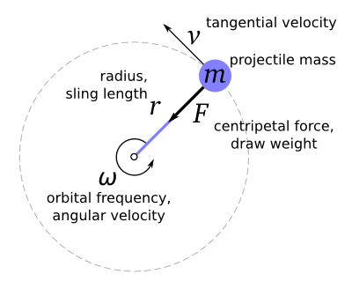

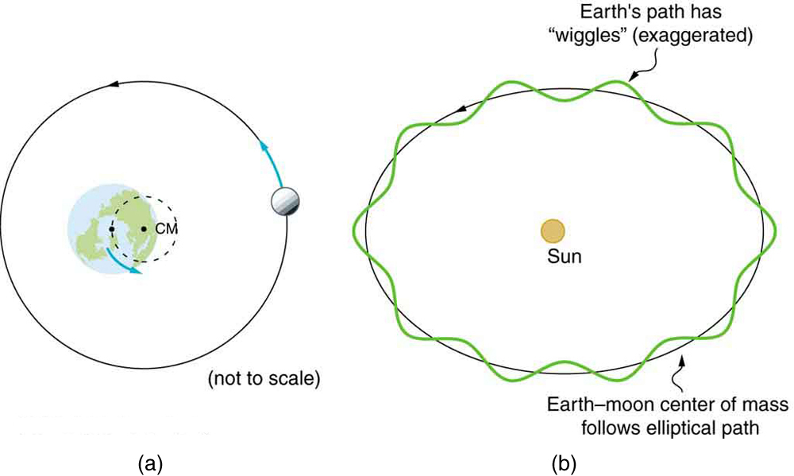
- Gravitational attraction between Earth and Moon keeps the Moon in circular motion around the Earth.

- Planes doing loops in the air. Air resistance pushing onthe plane’s wings keeps the plane in circular motion.
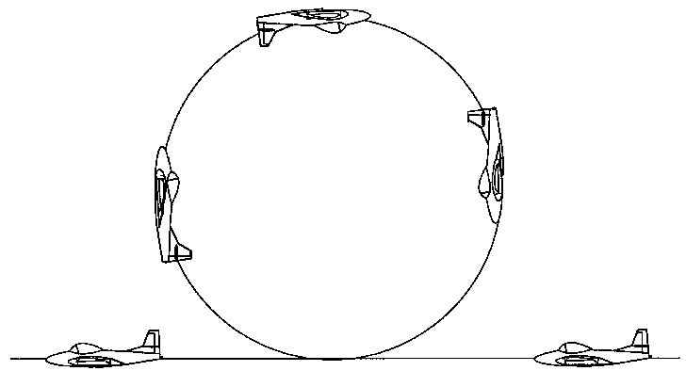

- A space shuttle is in orbit 400 km from the surface of the Earth and circles the Earth once every 90 minutes. Find the centripetal acceleration of the space shuttle in its orbit. Express this answer in”g’s”.

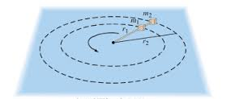
- Two blocks, of masses m₁ and m₂, are connected to each other and to a central post by cords as shown. They rotate about the post at a frequency of f on a frictionless horizontal surface at distances r₁ and r₂. Derive an algebraic expression for the tension in each segement of the cord.

Ball on a string

- A conical pendulum consists of an object attached to a string, swung in such a way so as to move the object in a horizontal circle. As the object is swung faster, the angle gets greater.

- The object can never have an angle of 90° as this would mean the speed of the object is infinity.

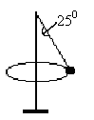
- In a game of totem tennis, a 0.120 kg ball is moving at a constant velocity in a horizontal circle around the pole as shown. The rope forms an angle of 25.0° to the pole and the horizontal radius of the ball is 1.20 m. The ball takes 3.22 s for one revolution.

- Draw and label the forces acting on the ball.

- The centripetal force is a resultant force of the tension and weight force so should not be shown on diagrams.

- What is holding the ball up?

- What is the ball’s acceleration?

- What is the tension in the string?

- A ball on the end of a conical pendulum is moving in a horizontal circle of radius R. The only two forces acting on the ball are the tension in the string, T, and the weight of the ball, mg.

A force diagram is shown.
T
The nett force, and
⊖
mg

Develop an equation for v in terms R, g and ⊖.
ΣF
Use this to show that ⊖ cannot reach 90°.

Leaning into a corner

- In many sporting events, the participants need to travel around corners at high speeds.
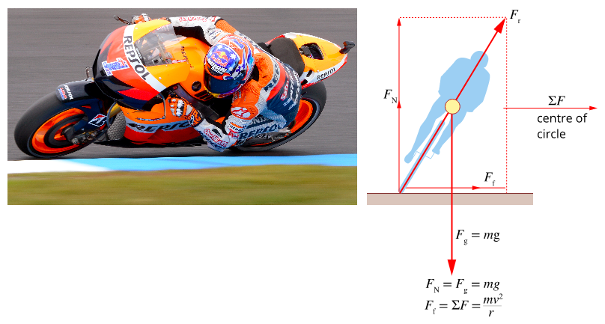
- Motorbike riders lean their bikes over almost to the track as they corner.
- This leaning technique is also evident in ice skating, bicycle races, skiing and even when you run round a corner. It enables the competitor to corner at high speed without falling over.

- In order to move in a circle, frictional force are required.
- There are two forces acting on the rider. Weight and reaction force from the ground.
- As the rider leans over, the horizontal component of the reaction force creates the centripetal force requird for circular motion. This is also equal to the frictional force.
- Since the rider is moving in a horizontal plane, the net force must be horizontal.


R
mg

The resultant force = F_{c}


- A cyclist and his bike have a combined mass of 80 kg. He is travelling at 36 km hr⁻¹ when he goes around a corner.

- Draw a free body diagram of the froces acting.

- If the radius of the corner is 20 m, at what angle does he lean?

Banked Tracks
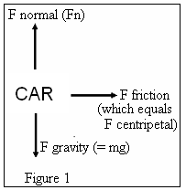
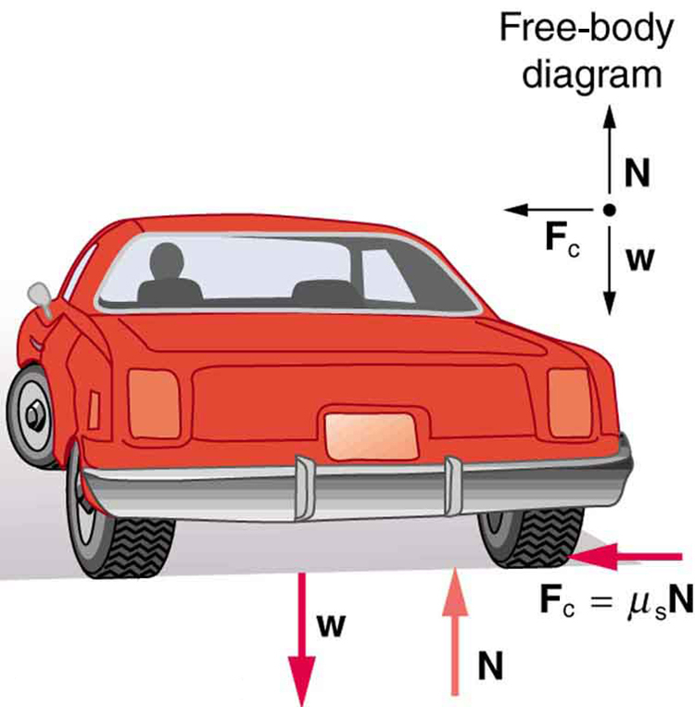
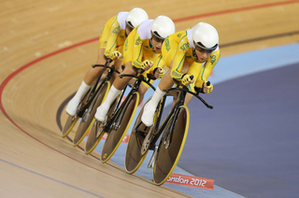

- Why do road and race track designers sometimes bank the road when it curves?

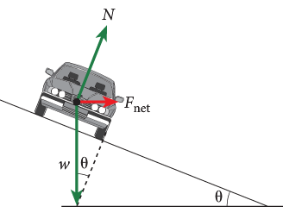
- When a car rounds a curve that is horizontal, the frictional force between the tyres and road surface supply the necessary centripetal force. The reaction force (or normal force) is the force of the road on the car due to its weight (mg).
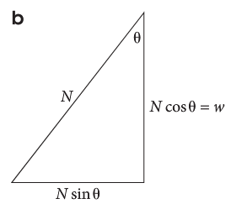

- If the road is banked at an angle to the horizontal, the horizontal component of the reaction force (or normal force N), supplies the centripetal force.

- The vertical component of N is equal to the weight of the car.

- In other words, the banking of curves can reduce the chance of skidding because the normal force of the road will have a component towards the centre of the circle thus reducing the need for friction.

- For a given angle of banking, there will be one speed for which no friction at all is required.

- This will be the case when the horizontal component of the normal force, N sinθ, is just equal to the force required to give a vehicle its centripetal acceleration – that is when Fn sin θ = mv²/r.

- The banking angle of a road, θ, is chosen so that this condition holds for a particular speed, called the “design speed”.

- The reaction force can be resolved into its components as shown below and from the triangle you can see that:
$$tanθ= \frac{F_{c}}{mg}= \frac{\frac{mv^{2}}{r}}{mg}$$
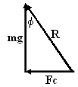
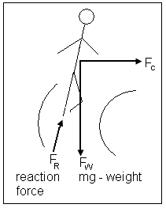
θ

so tan θ = v² where θ = angle of track
rg v = optimum speed for banked track
r = radius of curvature
v² = r g tan θ
g = 9.8 ms⁻²

- The formula above can also be used for objects that lean on a flat surface e.g. runners going around a corner will lean to enable them to increase their speed, likewise, motor cycles will lean when going around bends for the same reason.
- A civil engineer has to design a road in which there is a curve with a radius of 3.00 x 10² m. The road will have a maximum speed limit of 1.10 x 10² kmh⁻¹. At what angle should the road bank on the curve so that no frictional force is needed by a vehicle, travelling at the speed limit, to move round it.

- For a given angle of banking, there will be one speed for which no friction at all is required. If a driver or rider goes faster than this speed, they will require some friction to add to the extra centripetal force required to keep the object in circular motion.

- In the diagram, there are now three forces acting on the object – normal reaction force, N, friction force, f and weight force, mg.

- The object is still moving in a horizontal circle, so the net force must be horizontal.
  - The net force is equal to N sin θ + f cos θ.
  - Note: N cos θ ≠ mg

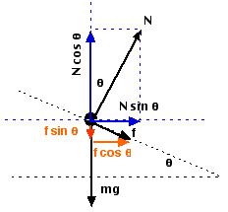

- A car track is banked at 15.0° and has a radius of 55.0 m. Compare the speeds that a 800.0 kg car could go if
- no friction is available.
- 5 000.0 N of friction is available and the normal force is 10 000.0 N

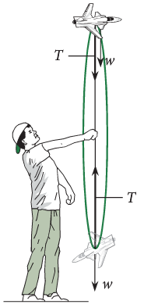
PP 2.5 p 73-76 2.5 Review p 77

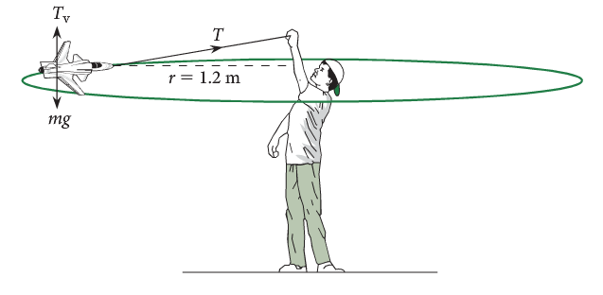

- In a horizontal circle, the tension is constant.
- In a vertical circle, the tension is lowest at the top of the circle and greatest at the bottom of the circle.

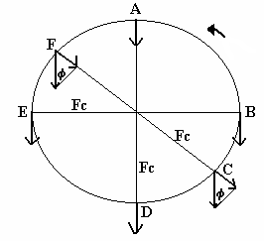
A Vertical Circle

Ball on a string

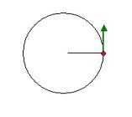

+ve

- In a horizontal circle, the force applied is always constant. However, in a vertical circle the force of gravity must be considered.

- As gravity is the same value and always acts downwards sometimes it assists the motion and sometimes it acts against the motion.

- For each situation, ΣF = ma. The overall ‘ma’ will create circular motion.

- Consider each of the points above on a vertical circle turning anticlockwise.

- At A, two forces act – weight and tension. Both forces are in the direction of the overall force.
ΣF
T
mg
+ve

- At B and E - no component of the weight force acts in the direction of the overall force.

mg
ΣF

- At D, two forces act – weight and tension. Tension is in the same direction as overall force, weight is in the opposite direction.
+ve
T
mg
ΣF

- A child is sitting on a swing and has been pulled back so that the seat is 0.500 m above the lowest point in the swing. The seat is then released.

- Calculate the velocity of the swing at its lowest point.

- Calculate the tension in the ropes of the swing when a 30.0 kg child is moving through the lowest point in the swing, which has a length of 1.50 m.
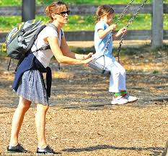

- At C, the two forces are weight and tension. The component of the weight force in the direction of the tension is given by mg sin φ.
T
mg
mg sin Φ
Φ
- In the bottom half of the circle, the tension will be
+ve
T

- At the very bottom, Φ = 90°, sin Φ = 1

- In the top half of the circle (F), the tension will be

- At the very top, Φ = 90°, sin Φ = 1
- In this course Φ will only be 90° or 0°.
- At the side, Φ = 0°, sin Φ = 0

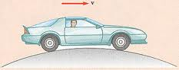
Car travelling on a road
mg
R

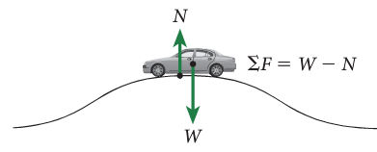

- At the top of a bump.

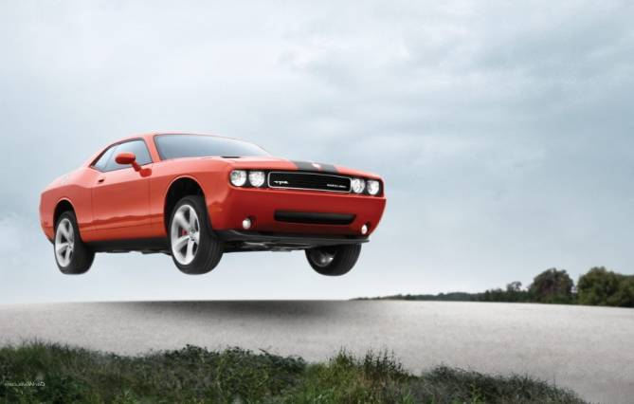
+ve

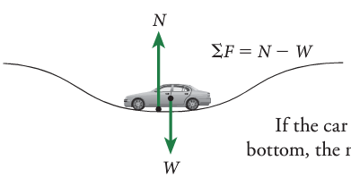

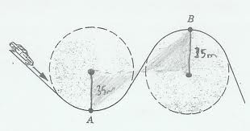
R
mg
- At the bottom of a dip.

+ve

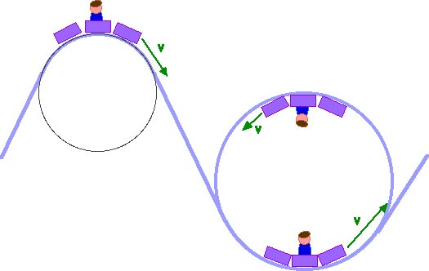
mg
R

Roller coasters

- At the top of the loop.

+ve


mg
R
- At the bottom of the loop.

+ve

To simplify

- To calculate tension in a rope (T) or reaction force (R):

  - at the bottom of a circle add

  - at the top of a circle subtract

  - at the side of the circle it will always be
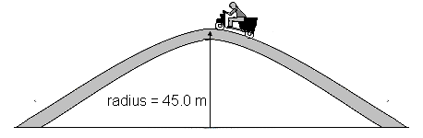
- A hump back bridge is constructed so it has a radius of 45.0 m. What is the maximum speed a motorcyclist can travel across the bridge without ‘lifting off the bridge’?

- Calculate the size of the acceleration in each of the following. The car has a mass of 50 kg.

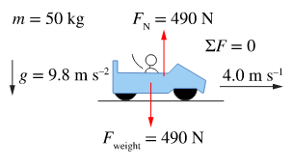 | 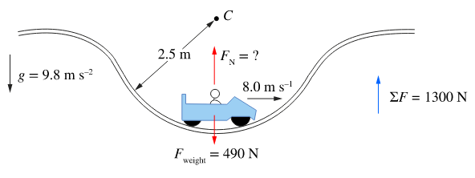 | 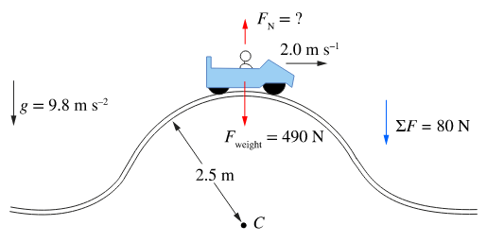

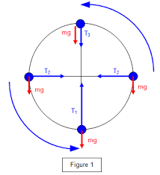
- A ball of mass 2.0 kg is being swung in a vertical circle, as shown. The string is 1.8 m long.
1
2
- If the speed of the ball at 2 is 14.0 ms⁻¹, calculate the speed at 1 and 3.

- Calculate the tension in the string at 1, 2 and 3

- A car of mass 150 g is released from rest from a height of 1.00 at point X. The car rolls down a frictionless track and performs a lop-the-loop.

- Calculate the speed of the car as it reaches the bottom of the loop, point Y.
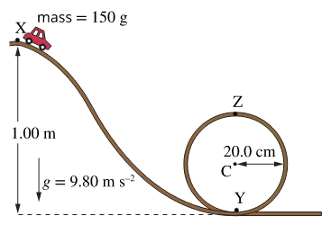

- Calculate the normal reaction force from the track at point Y.

- What is the speed of the car as it reaches point Z?

- What is the normal force acting on the car at point Z?

Artificial satellites are used for communication, navigation, remote-sensing and research. Their orbits and uses are classified by altitude (low, medium or high Earth orbits) and by inclination (equatorial, polar and sun-synchronous orbits). Communication via satellite is now used for global positioning systems (GPS), satellite phones and television. Navigation services support management and monitoring of traffic and aircraft movement. Geographic information science uses data from satellites to monitor population movement, biodiversity and ocean currents.

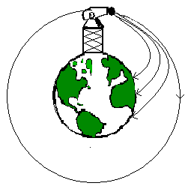
Gravitation Fields and Universal Gravitation

- Consider a tower several kilometers high with a horizontal canon on top. The velocity at which the cannon ball is fired is increased every time.

- Each time it falls back to the ground – except the last time where it keeps falling towards the Earth but the Earth curves away from it as it falls. It is in orbit – a satellite.

- All satellites, both artificial and natural, are in free fall and their acceleration depends only on where they are. Close to Earth the acceleration is 9.8 ms⁻². In much higher orbits they move slower and have a lower acceleration.

- Satellites must be in orbit beyond the Earth’s atmosphere to avoid air resistance.
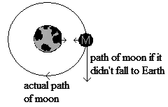
Satellite motion
- Newton believed that the force of attraction between the Earth and the Moon made the Moon continually fall towards the Earth instead of travelling off into space.

- The Earth provides a centripetal force on the moon that maintains its circular path around the Earth. This same force explains why planets maintain their orbits around the Sun.

- From circular motion we know that the centripetal force is equal to .
- However, we also know that the two bodies exert a force on each other .

- In circular motion these forces are the same value so F_{c} = F_{g.}

- Then, = ; cancel m_{o} then v² = G
To avoid air resistance
Why Do Satellites Stay in Space?

- It must be high enough above the Earth so that it escapes falling back to Earth.

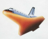
- Its horizontal velocity must be such that it makes a complete circular orbit of the Earth. Any less, it falls to Earth, any more, it escapes orbit.
At around 22 000 kmhr⁻¹, the space shuttle is going fast enough in order that’s
its falling trajectory shape matches the curvature of the Earth.

Note: At this point the tangential velocity is perpendicular to the force of
gravity and travelling parallel to the curve of the Earth – no component
of ‘g’ to change the speed.
- As centripetal force pulls the satellite to Earth it continually falls down towards the Earth’s surface which is itself continually curving away. The satellite swings in a circle above the Earth at a constant distance.
- Mathematically for a stable orbit, F_{c} = F_{g},

Gravitational Force Fields

- Remember, a force field can be thought of as a region of influence. Each body in space has its own force field and any object travelling in space experiences these forces. The nearer to the body an object moves, the stronger the gravitational pull and visa versa.

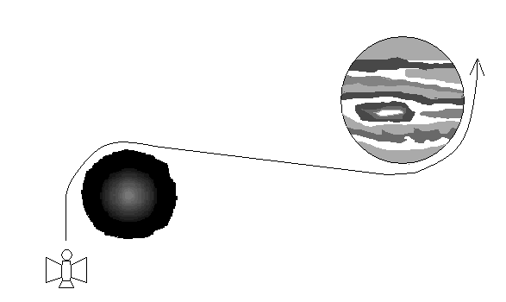
- Space travel has to take into account the effects of numerous gravitational fields. These can hinder progress by pulling a spacecraft off course or be used to advantage to sling-shot a craft into a new course without the use of fuel.

- Many space probes use the “sling-shot” approach when exploring our solar system to both change direction and increase speed.
- Main formulas for satellites are:
; ; ;
- These can be used to derive the following:
; ;
- You should know how to derive these!

- A satellite is circling Earth. If you are given the period of a satellite, T, derive an equation for finding its velocity, v.

- Calculate the approximate mass of the Sun by filling in the following data.

G =
T = 1 year =
r =

- Calculate the period of rotation of the Moon around the Earth by filling in the following data.

G =
r =
M_{earth} =

- What altitude, above the surface of the Earth, would a satellite need to be so that it was geosynchronous or geostationary (stays above one point on Earth)?

Newton’s Law of Universal Gravitation is used to explain Kepler’s laws of planetary motion and to describe the motion of planets and other satellites, modelled as uniform circular motion.
This includes deriving and applying the relationship

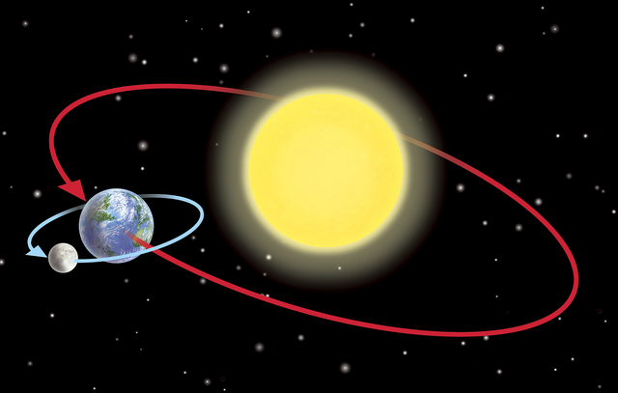

- Johannes Kepler developed 3 laws of planetary motion (80 years before Newton published his law of universal gravitation).
- His laws were developed for planets orbiting the Sun but can be used for any satellite that orbits a central mass.

Kepler’s Laws

- The planets move in elliptical orbits with the Sun at one focus.
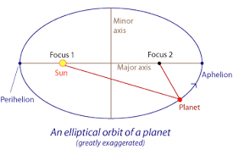

- The line connecting a planet to the Sun sweeps out equal areas in equal intervals of time.
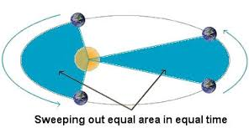

- For every planet, the ratio of the cube of the average orbital radius, R, to the square of the period, T, of revolution is the same, i.e. $\frac{R^{3}}{T^{2}}=constant, k.$

- Newton was able to show this relationship using his equations.

An object in circular motion has a force acting on it. $F= \frac{mv^{2}}{r}$.

Velocity equals distance on time. For a circle, $v= \frac{2 π r}{T}$.

Substitute v². $F= \frac{m4 π^{2}r}{T^{2}}$.

This force is equal to the gravitational force from the central mass. $F= \frac{G M m}{r^{2}}$.

Therefore, $\frac{G M m}{r^{2}}= \frac{m4 π^{2}r}{T^{2}}$

Rearranging, $\frac{r^{3}}{T^{2}}= \frac{GM}{4π^{2}}$ G, M and π are all constants.

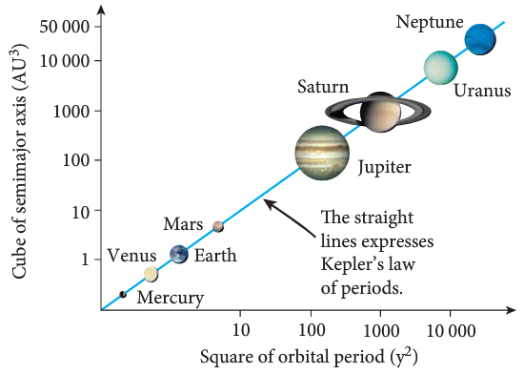

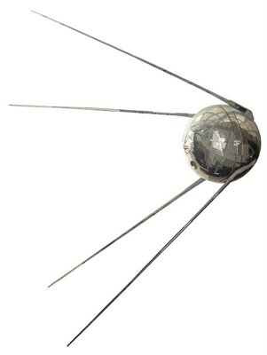
The Role & Impact of Artificial satellites

- The first satellite (Sputnik) was launched by the Russians in 1957. Its function was to measure the temperature, pressure and other information about the ionosphere.

- Its launch sparked a space race with the USA that culminated in the Apollo moon landing in 1969 by the Americans.

- The contribution of artificial satellites to improving the quality of human existence has been immense.

- Satellites in orbit are classified according to their orbit.
  - Low orbit – 180 km to 2000 km. Most satellites are in this range. E.g. Hubble Telescope.
  - Medium orbit – 2000 km to 36 000 km. E.g. GPS satellites.
  - High orbit – 36 000 km or greater. Communications satellites – geostationary.

- Satellites have different orbits depending on their function.
  - Equatorial orbits, satellites travel around the equator.
  - Polar orbits – satellites travel close to the North and South Poles
  - Inclined orbit
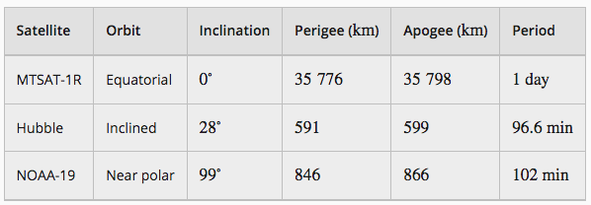

- The mass of the Sun can be determined by analysing the orbits of the natural satellites around it. Below is some data for 5 planets.

 | Distance from Sun 'R'  (millions of km) | Orbital period (T)  (years) | M (kg)
Venus | 108 | 0.62
Earth | 150 | 1.00
Jupiter | 778 | 11.86
Saturn | 1427 | 29.46
Uranus | 2870 | 84.01

Calculate the mass of the Sun for 3 planets by using for each set of data.

However, a graph of the data could be more helpful.

To determine M, what would you do to the data, what would you graph on each axis and how would you find M?

Revision Questions ANSWERS p 76
- A car is travelling at 72.0 kmh⁻¹ East when it rounds a corner to finally be travelling at 64.8 kmh⁻¹ North. If the change of velocity took place in 1.56 s, what was the car’s acceleration?

- A light plane, flying at 20.0⁰ above the horizontal has an airspeed of 136.8 kmh⁻¹. Find the plane’s rate of climb (vertical velocity).

- You are travelling in a hot-air balloon at 7.00 ms⁻¹, which is the same speed as the wind. If you hold a small flag in your hand, which way will the flag wave? Briefly explain.

- The pilot of a small plane is flying feedstock (bails of hay) to a stranded flock of sheep, trapped by rising floodwaters. The pilot skilfully flies at an altitude of 1.00 x 10² m when, travelling at 151.2 kmh⁻¹ horizontally, she releases a bail of hay. How far horizontally from the flock of sheep must she release the feedstock so that the bail of hay strikes the ground just before the sheep?

- a. An archer fires an arrow from a height of 1.20 m above the ground. If the initial velocity of the arrow was 32.0 ms⁻¹, and the archer fires the arrow at an angle of 28⁰ to the ground. How far away from him will the arrow hit the ground?
  - Explain one way in which the archer could have fired the arrow a greater distance without increasing the initial velocity.

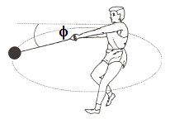
- At the Olympics, a hammer thrower spins the 7.26 kg hammer in a horizontal circle of radius 1.45 m, rotating 10 times every 13.4 s. The hammer thrower’s arms make a straight line with the hammer handle and at this speed the hammer makes an angle of φ to the horizontal as shown in the diagram.
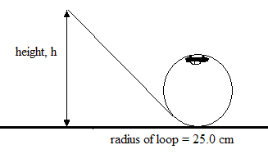
  - Calculate the centripetal force on the hammer.
  - Calculate the tension in the wire handle of the hammer.
  - Calculate the angle φ.

- A toy designer is in the process of designing a “loop the loop” racetrack for small toy cars. The designer is neglecting friction during the initial design phase. A sketch of the planned track is shown. Perform the necessary calculations that would show the starting height, h, required for the car to just complete one loop.

- A cyclist racing at a velodrome can corner at a speed of 60.0 kmh⁻¹ around a 40.0 m radius bend that is banked. Calculate the angle of the track to the horizontal.

- A planet with a small radius, A, has a large mass while a planet with a large radius, B, has a lower mass. Draw the fields around each planet.

- A satellite is orbiting 270 km above the Earth. Determine the acceleration due to gravity on the satellite.

- Calculate the force between the Earth and the Moon.

Errors

- Uncertainty of measurement is the doubt that exists about the result of any measurement. You might think that well-made rulers, clocks and thermometers should be trustworthy, and give the right answers. But for every measurement - even the most careful - there is always a margin of doubt.

- In everyday speech, this might be expressed as ‘give or take’ ... e.g. a stick might be two metres long ‘give or take a centimetre’.

Expressing uncertainty of measurement

- Since there is always a margin of doubt about any measurement, we need to ask ‘How big is the margin?’

- For example, we might say that the length of a certain stick measures 20 centimetres plus or minus 1 centimetre.

- This result could be written: 20 cm ±1 cm.

- The statement says that the stick is between 19 centimetres and 21 centimetres long.

- Error is the difference between the measured value and the ‘true value’ of the thing being measured.

- Uncertainty is a quantification of the doubt about the measurement result (±1 cm).

The measurement - how long is a piece of string?

- Suppose you need to make a careful estimate of the length of a piece of string. The process is as follows.
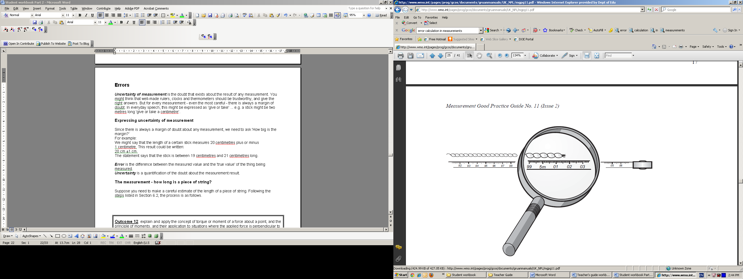
- Step 1. Carry out the measurements needed.
Align the tape measure along the string. Suppose you measure the length to be 5.017 metres (m).

- Step 2. Estimate the uncertainty.
To determine the uncertainty in a measurement, add and subtract one-half of the precision of the measuring instrument to the measurement.
The divisions on the tape are millimetres. Reading to the nearest division gives an error of no more than ±0.5 mm.
A digital voltmeter that reads 12.5 V will have an uncertainty of ±0.05 V.

- This process will give the absolute error.

- NOTE: Sometimes the uncertainty of the measuring equipment will be given. E.g. a hand held timer might have an accuracy of ± 0.005 sec. However, if a person is using the timer the uncertainty might be ± 0.1 sec due to reaction time.

Suppose you are measuring the time of ten swings of a short pendulum and five trials are performed.
The values are 15.2 s, 15.4 s, 15.1 s, 15.4 s and 15.0 s. This averages to 15.2 s.
Statistical analysis suggests that the average time should be given as 15.2 ± 0.2 sec

- Step 3. Calculate a percentage error if necessary.

If further calculations are required, a percentage error will need to be evaluated.

- Percentage errors are required in calculations involving multiplication and division.
In addition or subtraction – ADD ABSOLUTE ERRORS,
In multiplication and division – ADD PERCENTAGE ERRORS
⊕
For the following pictures, determine an absolute error and a percentage error.
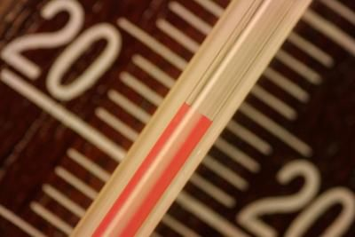

Temperature =

Temperature =

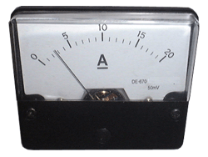

Current =

Current =

- A student wishes to determine the specific heat of water. He measures the mass of a sample of pure water to be 0.542 ± 0.005 kg. The initial temperature of the water is 19.5 ± 0.5 °C. He places the water in an insulated container and heats it up using a device that can measure the amount of heat going into water. After a few minutes, the student determines that 95.5 ± 1 kJ of heat was put into the water and the final temperature was 62.0 ± 0.5 °C. Using this information, determine the specific heat of the water and the absolute error to see if the value is within the accepted value.

Graphing

- Graphing data is an important process in Physics. Being able to plot data and manipulate data to determine information is an essential skill.

- Some things to consider when graphing!
- Title
- Labelled axes
- Units on axes (if appropriate)
- Is the origin (0,0) included
- Draw a line of best fit (or curve of best fit)
- If the graph is a curve, can the data be manipulated to give a straight line?
E.g. a car accelerates from rest and the velocity over time is recorded. What is the acceleration of the car?
Time | Displacement
0 | 0
1 | 1
2 | 4
3 | 9
4 | 16

  - A graph of s against t will give –

s

t

  - The acceleration cannot be determined from this graph.

- What does the slope of the graph represent? Can this be used to determine information?

  - A graph of v against t² will give –
u = 0
so s = ½ at²

a graph of s against t² will have a slope of ½ a

∴a = 2 x slope
s

t²

- In graphing, it is often important to include the errors in the graphing process. This can be done by including “error bars” on the graph.

- A line of best should be a line that goes through all the point within the error bars.

- Error bars are a graphical representation of the variability of data and are used on graphs to indicate the error, or uncertainty in a reported measurement.

- A scientist wants to determine the mass of the Earth by analysing the movement of satellites around the Earth. He selects 6 satellites and measures their period of rotation and their distance from the centre of Earth. The data is listed below.

Name | Use | Orbital period T (x 10³ sec) |  | Orbital radius r (x 10⁶ m)
Landsat 5 | Monitor Earth resources | 5.93 |  | 7.07
Hubble | Space telescope | 5.79 |  | 6.96
COBE | Astronomy research | 6.16 |  | 7.25
MIR | Space station | 5.54 |  | 6.76
AO 27 | Amateur radio communication | 6.06 |  | 7.17
NOAA 12 | Monitoring weather | 6.08 |  | 7.12
SATELLITE PERIOD AND RADIUS
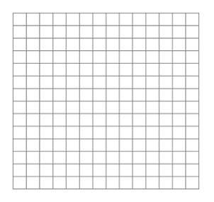
Assume that each value of T² and r³ have an error of 2%.

2% of 3.5 = 0.07 ~ ± 0.1

Each error bar ~ same.
Radius cubed

X 10 ²⁰ m³
3.0
3.8
3.6
3.4
3.2
4.0
3.8
3.6
3.4
3.2
3.0
Period squared

X 10⁷ s²

- Calculate the slope of the graph.

- You should include units for slope.
- Using the value for the slope and the formula below, determine the mass of the Earth.

- Sometimes an error is not due to the accuracy of the measuring equipment and an appropriate error needs to be estimated.
⊕
What is the diameter of the circle below?

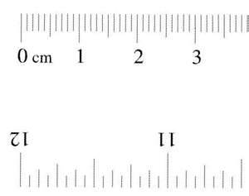



3.3 cm 3.1 cm 3.3 cm

Using the first result, the diameter is
By using other results, saying that the diameter is would be more accurate

- A student is watching a dripping tap. He wants to determine the time interval between the drips. To increase the accuracy he times for ten drips. The timer gives a value of 12.65 sec and the packet that the timer came in suggests the timer is accurate to within 0.01 sec. Work out an appropriate uncertainty for the time between drips (absolute and percentage).

When an object experiences a net force at a distance from a pivot and at an angle to the lever arm, it will experience a torque or moment about that point.
This includes applying the relationship


A review of centre of mass

- The centre of mass (COM) is a point in or near an object where the average mass is and can therefore represent a point where all of the mass can be thought of to be, for the purposes of calculation.

- In practice it must be the balance point of the object. If all of the mass were concentrated at this centre of mass, then the object would behave in the same way.
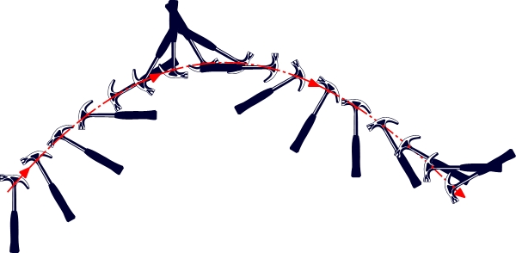
- The centre of gravity (COG)is a point on the object where the average weight acts.

- Once the centre of gravity is known, then all of the weight of the object can be thought of as acting at or from this one point which greatly simplifies calculations.

- For all calculations, assume that COM and COG are the same point.
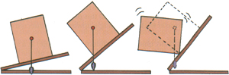
Stable
Unstable
Stability

- An object is stable if it will not topple over. When COM is over the
base it is stable. If disturbed, the COM is lifted but it returns to its
original position.

- If the COM passes outside the base of an object, it becomes topple.

- The closer the centre of mass of an object is to the ground and the larger the base, the more stable the object is.

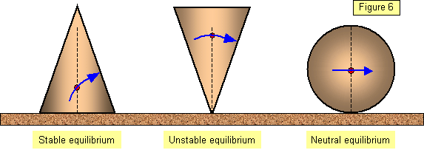
- Greatest stability comes from low centre of mass and large area (base) over which the centre of mass acts. A large force is then required to move the centre of mass beyond the base.

- Stable:
Stable position with centre of mass over the base. Slight movement has no overall effect - centre of mass may be raised but object returns to its original position


- Unstable:
Centre of mass is over the pivot. Slight movement causes object to move resulting in a new, often lower, centre of mass.

Neutral:
Centre of mass is over the pivot. Slight movement causes object to move

to a new position although the centre of mass usually remains at the
same height.

Torque (or moment of a force)
- A torque or moment of a force is a turning effect created when a linear force is applied to a lever arm with a pivot and the object rotates.
τ = F x r x sin ⊖ where τ = torque or moment in Nm
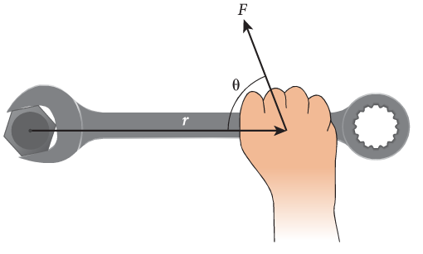
F = applied force at 90⁰ in N
r = distance of point of application
of force from pivot point
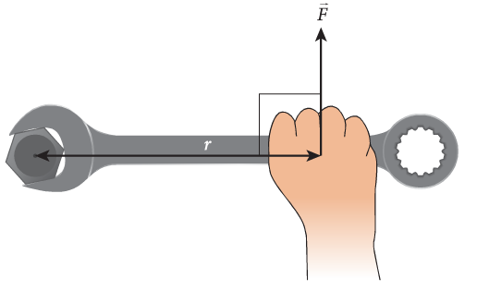
⊖ = angle between lever and force.

- When F and r are perpendicular, maximum torque occurs. τ = F x r

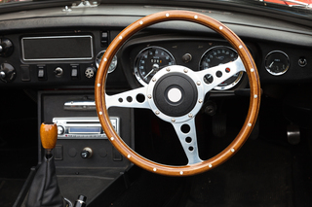

Applying a torque to a steering wheel will
cause it to turn.

Example:
You pick up a hammer that has a mass of 1.25 kg. You are holding it 15.0 cm from the centre of mass. What is the value of the moment of force you are applying to keep the hammer horizontal?

F = mg Always draw a diagram τ = Fr
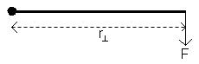
= 1.25 x 9.8 = 12.25 x 0.150
= 12.25 N = 1.8375
r = 0.150 m τ = 1.84 Nm

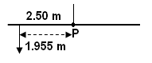
- Jasmine, who has a mass of 35.0 kg, is sitting on a uniform seesaw which is 5.00 m long and pivoted in the middle. She is sitting 0.545 m from one end. What torque does she produce?

- A 24.0 kg pelican is sitting at the end of a uniform horizontal support pole for a street lamp The support pole is 0.750 m long and has a mass of 10.0 kg. Calculate the torque on the pivot point of the street lamp.
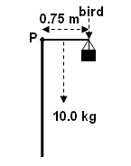

- When calculating a torque, you need to multiply the force by the perpendicular distance.

- This is straight forward if the force and lever at right angles.
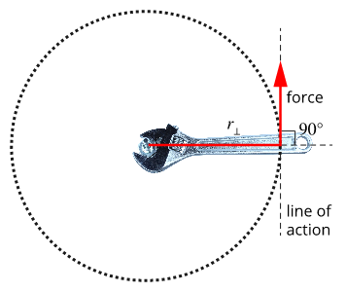

r
F
hinge (bolt)

τ = F x r

- Note: in the above situation the spanner is applying an anticlockwise torque to shift the nut. The nut is resisting this torque and applies a clockwise torque. If the anticlockwise torque is large enough, the nut will shift.

- How can the task of shifting the nut be made easier?

- However, the force and the lever are not always at right angle to each other. If this is the case, there are a number of ways to calculate the torque.

  - Measure the angle between the force and the lever.
r
F
⊖

τ = F x r x sin ⊖

  - Find a component of the force that is perpendicular to the lever.
r
F
⊖
F sin ⊖

τ = F x r
τ = F sin ⊖ x r
τ = F x r x sin ⊖

  - Extend the force line until a perpendicular line can be drawn to the hinge.
r
F
⊖
d
τ = F x d d = r sin ⊖
τ = F x r x sin ⊖

- A mechanic applied a force to the end of a wrench in an attempt to undo the nut. The effective length of the wrench is 17 cm and he applies a force at an angle of 25° to the wrench. If the nut requires a torque of 18 Nm to move it, how much force will the mechanic need to apply?
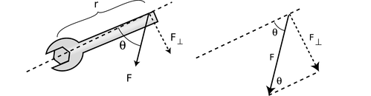

For a rigid body to be in equilibrium, the sum of the forces and the sum of the moments must be zero
This includes applying the relationships

Conditions for Equilibrium
- For an object to be in equilibrium, it must either be at rest or moving at constant velocity.

- This means that all of the forces acting on it must be balanced.

- All the forces acting downwards on the object must equal all of the forces acting upwards.
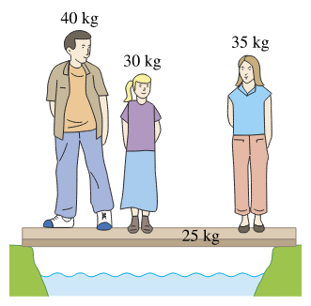
- Similarly, all the forces acting left must equal all the forces acting right.

- The plank in the diagram above is in equilibrium.
- The upward forces provided by the supports balance the downward forces from the people and the plank. There are no forces left or right.

    - How much force is provided by the supports?

- This is also true for objects that could rotate.
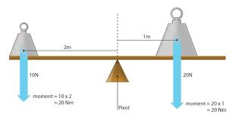
- Consider the turning situation is a seesaw. The point about which the turning occurs is called the fulcrum or pivot.

- The magnitude of the weights (force) placed either side of the fulcrum as well as where the weights are placed (perpendicular distance of force) can cause an imbalance.
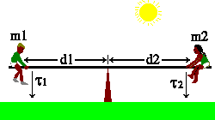
- When a turning forces are in balance e.g. in a seesaw balanced horizontally with masses on either side, it is in a state of stable equilibrium. The moments clockwise must equal the moments anticlockwise.

- At this point two conditions exist. The sum of the forces equals zero and the sum of the moments equals zero.

ΣM = 0 or Στ = 0

sum of the clockwise moments = sum of anti-clockwise moments
ΣCWM = ΣACWM

ΣF = 0
sum of forces up = sum of forces down sum of forces left = sum of forces right
ΣF_{up} = ΣF_{down} ΣF_{left} = ΣF_{right}

Equilibrium of Vectors – Resolving Vector Forces

- Some equilibrium problems can be solved by having an understanding of resolving vector forces.

Example:
A street lamp weighing 50 kg, hangs from two poles as shown below. Calculate the tension in each wire.
The object is not moving.
So, all the force up = all the forces down AND all the forces left = all the forces right. It is in EQUILIBRIUM.
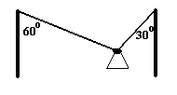

1. Resolve the forces into horizontal and vertical components.

2. Compare the horizontal forces. As the lamp is not moving, we know that the sum of all the
horizontal forces = 0 (ΣF_{X} = 0). or forces left = forces right

T1 cos 30⁰ = T2 cos 60⁰
0.866 T1 = 0.5 T2
therefore T1 = 0.5774 T2 → equation 1

3. Compare the vertical forces. As the lamp is not moving, we know that the sum of the vertical
forces = 0 (ΣF_{Y} = 0) or forces up = forces down

T1 sin 30⁰ + T2 sin 60⁰ = 490
0.5 T1 + 0.866 T2 = 490 → equation 2

substitute equation (1) into equation (2)

0.5 (0.5774 T2) + 0.866 T2 = 490
0.2887 T2 + 0.866 T2 = 490
1.1547 T2 = 490
T2 = 424 N

4. Substitute for T2 back into equation (1)

T1 = 0.5774 T2
= 0.5774 x 424
= 245 N

5. Write down answer: T2 = 424 N
T1 = 245 N

- Another method is to draw a triangle of forces.
- The three forces create a closed triangle.
- This indicates that all the forces are balanced and the net force is zero.

- Use cos rule or sin rule to find T1 and T2.

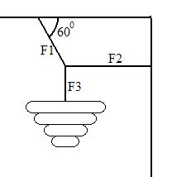
- A chandelier is hanging from a ceiling as shown. The mass of the chandelier is 200 kg. Find the forces F1, F2 and F3.

- A lamp of mass 4.80kg is suspended over the centre of a 15.0m wide road by means of two wires running to the tops of two 7.00m high poles on either side of the road. If the lamp is suspended 6.50m above the road, calculate the tensions in the wires.

Equilibriums involving torques

- When problems involve moments, for equilibrium to be established, the moments clockwise must balance the moments anticlockwise.
- In addition, the forces must be balanced.

Example
A boy of mass 45.0 kg sits 1.50 m from the pivot point of a seesaw on the right hand side. Where must a girl of mass 40.0 kg sit in order for the seesaw to balance?

take moments about P
for balance ΣM = 0
Always draw a diagram BOY F = ma therefore ΣCM = ΣACM
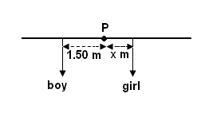
F = 45 x 9.8 Fr⊥ (boy) = Fr⊥ (girl)
F = 441 N 441 x 1.5 = 392 x r (girl)
r⊥ = 1.5 m r (girl) = 441 x 1.5
GIRL F = 40 x 9.8 392
F = 392N r (girl) = 1.69 m
r⊥ = ?
Girl is sitting 1.69 m from the left of the centre (fulcrum)

- Always state where you are taking the moments from. This is particularly important in your WACE Examination. In last year’s TEE, 1 mark was given for this in a difficult question.

- A man weighing 840 N sits on a seesaw 1.50 m from the pivot. His son and daughter sit on the other side and balance it. The girl weighs 4.20 x 10² N and is 0.900 m from the pivot. What is the weight of the boy who sits 1.80 m from the pivot?

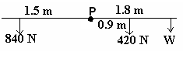

- A man holds a 50.0 N ball in his arm as shown below. The pivot point is the elbow and the forearm weighs 15.0 N. Calculate the force the muscles (M) must apply for the arm to hold the ball horizontal.

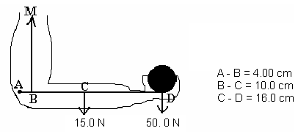

- What are the forces F₁ and F₂ that the supports exert on the diving board shown in the diagram below, when a 45.0 kg girl stands at the end of the board, if the mass of the board is 25.0 kg?
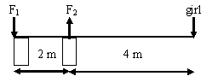

Redraw diagram.

- Forces are vector quantities so you should include a direction.

- A uniform metre rule of mass 0.800 kg has a mass of 0.200 kg suspended at the 90.0 cm mark. At what point must the rule be supported in order to balance?
0.800 kg
0.200 kg
F

A suggested approach to problem solving
- Marks are awarded for working and if you go through this process you can often get more than 50% of the marks, even if you cannot solve the equations, perhaps even if you get the equations wrong. You must always show all working.

- Read question carefully and form a mental picture of the situation then identify the object that is in equilibrium including its pivot point.
- Draw a large clear fully labelled diagram. Use a ruler and pencil.
- Identify the forces acting on the object that is in equilibrium and put them in the diagram in correct position.
- Identify the unknown forces and angles required by the question and mark them in the diagram. Give them a symbol.
- Check that you have all the forces correctly shown. Show only forces acting on the object in question.
- Take moments about the point of action of the force with unknown direction (if applicable).
- Equate the components of the forces horizontally and vertically to zero. ΣF_{H} = 0 ΣF_{V} = 0
- Solve for the unknowns. Be careful with the mathematics.
- Give direction of vector. Check you have the correct number of significant figures & the correct units.

Equilibrium involving moments and forces
- For a body to be in equilibrium (not moving at all),
ΣM = 0 (sum of moments equals zero) and ΣF = 0 (sum of forces equals zero).
- These are known as the conditions for equilibrium.

FORCES AT RIGHT ANGLES

Bridges
- Bridge problems are those that have a beam supported by two pillars at each end. Masses are supported by the beam. To solve, use ΣF_{up} = ΣF_{down}.

            - Free body diagram

mg
mg
F
F

mg
mg
T
T
- Platforms suspended by cables are similar.

- A 20.0 m long bridge is supported at each end by pillars. The bridge has a mass of 3.52 x 10⁴ kg. On the bridge is a truck which has a mass of 2.60 x 10³ kg and a car which has mass of 985 kg. The truck is 4.00 m from one end and the car is 5.00 m behind the truck. Calculate the force on each pillar.

Diving boards
- These problems usually involve a board supported at two point, supporting a weight that is beyond one of the support points. To solve, use ΣF_{up} = ΣF_{down} and ΣCWM = ΣACWM

            - Free body diagram of board only
mg
mg
F
F

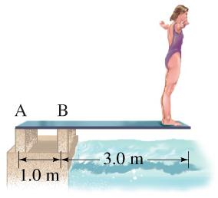
- Calculate the forces F_{A} and F_{B} that the supports exert on the diving board when a 60 kg person stands on its tip. The board has a mass of 15 kg

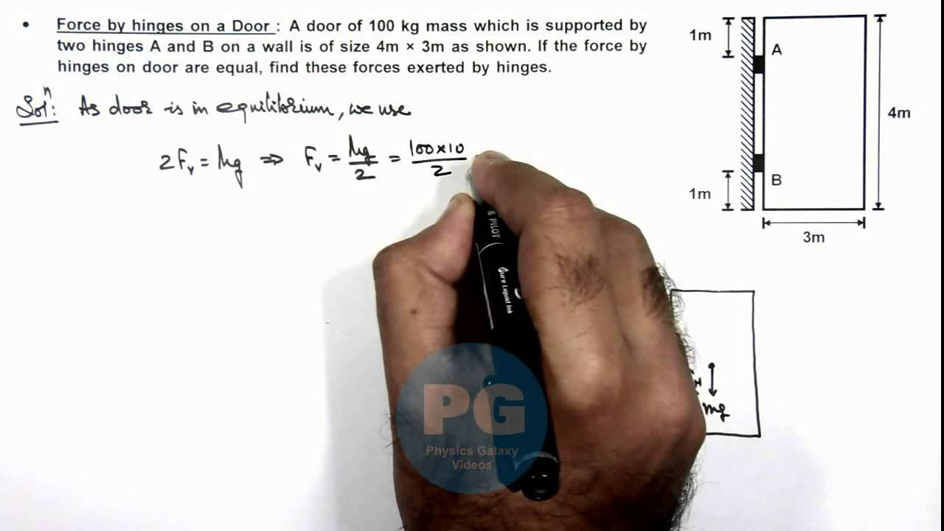
Doors
- A door of mass 100 kg mass is supported by two hinges, A and B, on a wall of size 4 m x 3 m.
Draw the forces on the diagram.
The force on each hinge is the same. Find the force on each hinge.

FORCES NOT AT RIGHT ANGLES

Signs
- Sign problems are those that have a beam supported by a cable attached to a wall. Masses are supported by the beam. To solve, find a component of the tension in the cable, then use ΣCWM = ΣACWM and ΣF_{up} = ΣF_{down}.

            - Free body diagram of beam only
T
mg
R
mg

- The diagram below shows a sign hanging in front of a shop. If the sign weighs 2.40 x 10² N and the angle the rope makes with the bar is 55⁰ (angle near the coffee sign), how much tension is in the rope? (Assume the bar weighs 5.00 kg and is 0.800 m long.)

- When dealing with angles in moments, students sometimes forget to multiply by the distance. For example, in the example above, the anticlockwise moment is (T sin 55 x 0.80)

- In order to find the reaction force from the wall, R, there are a number of ways to do this.
T
mg
R
mg
- R_{V} + T_{V} = mg + mg and R_{X} = T_{X}

- Or, a triangle of forces could be drawn to solve for R.

- There are a number of ways that sign problems can be given.

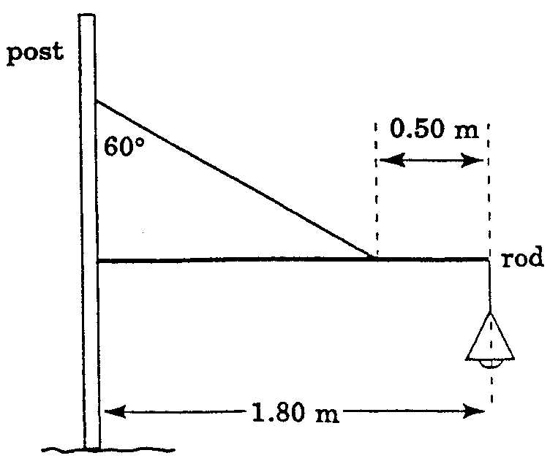

- A street lamp of mass 2.25 kg is suspended above the roadway from one
- end of a horizontal rod, 1.80m long, which is fastened at its other end to a
- vertical post. The mass of the rod is 3.00 kg. It and the lamp are partly
- supported by a light cable, attached 50.0 cm from the lamp and making
- an angle of 60.0⁰ with the vertical post to which the other end is fastened.

Calculate the tension in the cable and the direction and magnitude of the force the post exerts on the rod.

Ladders
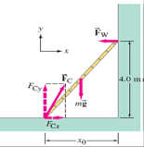
- The ladder is fixed into the ground so it cannot slide.
- F_{c} in the diagram is the force provided to the foot of the ladder.
- It does not necessarily go at the same angle as the ladder.

- The wall is usually smooth.
- This means that F_{w} from the wall only has a horizontal component.

- The ladder has a mass, usually in the centre of the ladder.
- There are sometimes people standing on the ladder.

- In this example, F_{w} = F_{cx} and F_{cy} = mg.

- Taking moments about F_{c} can be used to solve the forces.

- A 5.0 m long ladder leans against a wall at a point 4.0 m above a cement floor as shown. The ladder is uniform and has a mass of 12.0 kg. Assuming the wall is frictionless (but the floor is not), determine the forces exerted on the ladder by the wall and the floor.

Boom crane
- Here, the cable is under tension (it pulls inward) and the boom is under compression (it pushes outward). At the top of the boom, forces here must be at equilibrium. To solve, find all the components of the forces, then use ΣF_{up} = ΣF_{down}.

            - Free body diagram of boom only
T
mg
R
mg

$$ΣF_{up}=ΣF_{down}$$
$$T sinθ+mg+mg=R sinϕ$$

$$ΣF_{left}=ΣF_{right}$$
$$R cosϕ= T cosθ$$
⊖
T
mg
R
T cos⊖
T sin⊖
R sinΦ

R cos Φ

Φ

or
mg

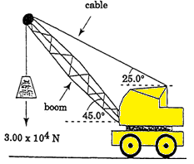
- Find the tension in the cable and the compression in the boom. Assume the mass of the boom is negligible compare to the load carried.

Free body diagram of boom only

- If you stand with your left side and left foot against the wall you will fall over if you lift your right foot. Explain, using the concept of torque then estimate the amount of torque causing you to fall over in the situation described above.

- A long bridge of mass 1.00 x 10⁴ kg is supported by two large columns as shown. The centre of mass of each column is 24.0 m apart. If a 9.00 x 10² kg car is two-thirds of the way across the bridge, what is the force each column is supporting?
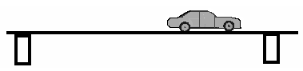

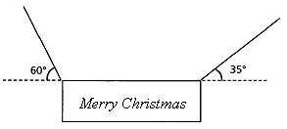
- A large uniform sign of mass 40.0 kg is suspended over Victoria Street in Bunbury as part of the Christmas decorations. It is supported by two cables attached to buildings either side of the street. Calculate the tensions in the cables.

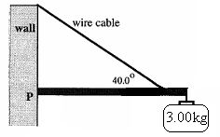
- The diagram shows a wall bracket used to hang a sign from a wall. The dimensions of the wall bracket are as follows:
Mass beam = 1.50 kg
Length beam = 1.00 m
Wire attached 0.750 m along beam
Find:
a. The tension in the wire cable.
b. The compression in the beam.
c. The reaction at the wall, point P.

- A lawn roller of mass 2.00 x 10² kg and radius 40.0 cm is being pulled over a step as shown. The step is 8.00 cm high and the handle is horizontal.

- What force is required to cause the roller to begin moving
- At what angle to the horizontal will the least force be needed to pull the roller over the step. Justify your answer with appropriate calculations.

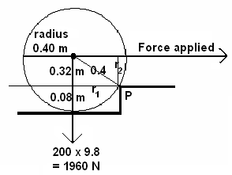

ANSWERS: Revision Questions page 56
- A car is travelling at 72.0 kmh⁻¹ East when it rounds a corner to finally be travelling at 64.8 kmh⁻¹ North. If the change of velocity took place in 1.56 s, what was the car’s acceleration?
u = 72 kmh⁻¹
= 20 ms⁻¹ east = 26.91 ms⁻¹
v = 64.8 kmh⁻¹ φ = tan⁻¹ (20 ÷ 18)
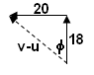
= 18 ms⁻¹ north = 48.0⁰
v-u = 18 N – 20 E
= 18 N + 20 W a = 17.25
t = 1.56 s a = 17.3 ms⁻² N 48⁰ W

- A light plane, flying at 20.0⁰ above the horizontal has an airspeed of 136.8 kmh⁻¹. Find the plane’s rate of climb (vertical velocity).
v = 136.8 kmh⁻¹ v_{v} = V sin 20
= 38 ms⁻¹ = 38 sin 30
v_{v} = 13.0 ms⁻¹

- You are travelling in a hot-air balloon at 7.00 ms⁻¹, which is the same speed as the wind. If you hold a small flag in your hand, which way will the flag wave? Briefly explain.
As you are moving at the same speed and direction as the wind, no n et horizontal force on the flag so the flag hangs limp;

wind
speed of flag relative to balloon is zero.
balloon as no wind, flag is limp

- The pilot of a small plane is flying feedstock (bails of hay) to a stranded flock of sheep, trapped by rising floodwaters. The pilot skilfully flies at an altitude of 100.0 m when, travelling at 151.2 kmh⁻¹ horizontally, she releases a bail of hay. How far horizontally from the flock of sheep must she release the feedstock so that the bail of hay strikes the ground just before the sheep?
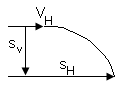
s_{v} = 100 m s_{v} = u_{v}t + ½ gt² s_{H} = v_{H} x t
v_{H} = 151.2 kmh⁻¹ 100 = 0 + 4.9t² = 42 x 4.5175
= 42 ms⁻¹ t = 4.5175 s s_{H} = 189.74 m
g = 9.8 ms⁻¹ need to release hay 190 m from sheep.

- a. An archer fires an arrow from a height of 1.20 m above the ground. If the initial velocity of the arrow was 32.0 ms⁻¹, and the archer fires the arrow at an angle of 28⁰ to the ground. How far away from him will the arrow hit the ground?
b. Explain one way in which the archer could have fired the arrow a greater distance without increasing the initial velocity.
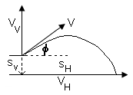
a.
s_{v} = -1.20 m v_{v}² = u_{v}² + 2gs
g = -9.8 ms⁻¹ = 15.023² + (2 x -9.8 x -1.2)
u_{v} = 32 sin 28 = 225.69 + 23.52
= 15.023 ms⁻¹ = 249.21
u_{H} = 32 cos 28 v_{v} = 15.786 ms⁻¹ down
= 28.254 ms⁻¹ t = (v-u) ÷ g
= (-15.786-15.023) ÷ 9.8
= 3.1438 s

s_{H} = 28.254 x 3.1438
s_{H} = 88.8 m

b. Increase angle to around 45⁰


- At the Olympics, a hammer thrower spins the 7.26 kg hammer in a horizontal circle of radius 1.45 m, rotating 10 times every 13.4 s. The hammer thrower’s arms make a straight line with the hammer handle and at this speed the hammer makes an angle of φ to the horizontal as shown in the diagram.
  - Calculate the centripetal force on the hammer.
r = 1.45 m
T = 13.4 ÷ 10
= 1.34 s
m = 7.26 kg
F_{c} = 231 N

  - Calculate the tension in the wire handle of the hammer.
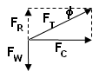
F_{w} = mg = 7.26 x 9.8
= 71.148 N =
F_{R} = reaction to weight F_{T} = 242 N
equal magnitude

  - Calculate the angle φ.

φ = tan⁻¹ (71.148 ÷ 231.45)
φ = 17.1⁰

- A toy designer is in the process of designing a “loop the loop” racetrack for small toy cars. The designer is neglecting friction during the initial design phase. A sketch of the planned track is shown. Perform the necessary calculations that would show the starting height, h, required for the car to just complete one loop.

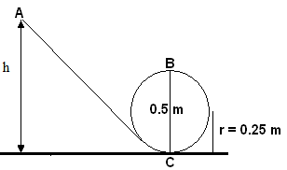
Total energy throughout system is conserved
E_{T} at A = E_{K} + E_{P} but E_{k} = 0 so
= mgh(A)
E_{T} at B = E_{k} + E_{p}
= ½ mv² + mgh(B)

now as in a circle and need minimum velocity to maintain circle, F_{c} = F_{w} (weight)
so equating formulas: v² = rg at point B

now total energy, E_{T}, is constant therefore energy at A
must equal energy at B
mgh(A) = ½ mv² + mgh (B)
also v² at B = rg so
mgh(A) = ½ mrg + mgh(B)
g and m will cancel throughout
h(A) = ½ r + h(B) and height at B = 0.5 m so
h(A) = (½ x 0.25) + 0.5
= 0.625 m

so release height for car is 0.625 m

- A cyclist racing at a velodrome can corner at a speed of 60.0 kmh⁻¹ around a 40.0 m radius bend that is banked. Calculate the angle of the track to the horizontal.
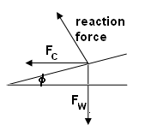
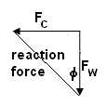
F_{w} = mg
v = 60 ÷ 3.6 = 16.666 ms⁻¹

tan φ =
tan φ =
φ = 35.2⁰

- A planet with a small radius, A, has a large mass while a planet with a large radius, B, has a lower mass. Draw the fields around each planet.
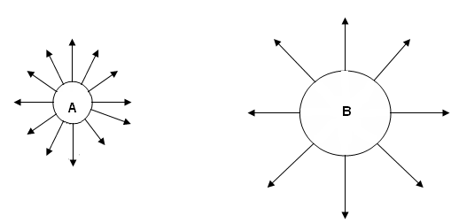

- A satellite is orbiting 270 km above the Earth. Determine the acceleration due to gravity on the satellite.
r_{T} = r_{E} + r_{s}
= 6.37 x 10⁶ + 270 000 g’ = 9.05 ms⁻²
= 6 640 000 m
m_{E} = 5.98 x 10²⁴ kg

- Calculate the force between the Earth and the Moon.
r_{E-m} = 3.84 x 10⁸ m
F_{g} = 1.99 x 10²⁰ N
m_{m} = 7.35 x 10²² kg
m_{E} = 5.98 x 10²⁴ kg

- At what speed must a satellite be travelling so that it shall remain in a circular orbit 1.60 x 10³ km above the earth’s surface?
G = 6.67 x 10⁻¹¹ F_{c} = F_{g}
m_{E} = 5.98 x 10²⁴ kg
r_{T} = r_{E} + r_{s} m_{s} and r cancels
= 6.37 x 10⁶ + 1 600 000
= 7970000 m v² = 50045922
v = 7074

speed = 7.07 x 10³ m

